Eye in a Disk: eyeIntegration human pan-eye and body transcriptome database version 1.00

Vinay Swamy1, and David McGaughey1,✉

January 23, 2019

PURPOSE: To provide the eye community with a high quality RNA-seq based transcriptome expression database of healthy human eye tissues and a matching reactive web application to query gene expression in eye and body tissues. METHODS: We downloaded the raw sequnce data for 892 RNA-seq based samples across over 44 tissues in the GTEx project as a non-eye reference set. We then queried several public repositories to find all healthy, non perturbed, human eye tissue RNA-seq samples. The 1311 total samples we found are sent into a Snakemake-based reproducible pipeline we wrote. The pipeline automatically quantifies all known transcripts and genes, removes samples with poor sequence quality and likely mislabeling, normalizes expression values across each tissue, performs 105 differential expression tests, calculates GO term enrichment, and outputs all as a single SQLite database file: the Eye in a Disk (EiaD) dataset. RESULTS: As 40+ GB database is not a useable format for most, we rewrote the web application eyeIntegration (version 1.00, <https://eyeIntegration.nei.nih.gov>) to display this data, focusing on providing users quick visualizations by database version, gene/transcript, and 60 tissues. In a powerful demonstration of the value of this unified pan-eye dataset, we agnostically show that, at a transcriptome level, fetal, stem cell, and organoid retina tissues are highly similar. CONCLUSION: The eyeIntegration v1.00 web app serves the pan-eye and body transcriptome dataset, EiaD. This provides the eye community a powerful and quick mean to testing hypothesis relating to human gene and transcript expression across 44 body and 16 eye tissues.

1 Ophthalmic Genetics and Visual Function Branch, National Eye Institute, National Institutes of Health

✉ Correspondence: [David McGaughey <[mcgaugheyd@mail.nih.gov](mailto:mcgaugheyd@mail.nih.gov)>](mailto:mcgaugheyd@mail.nih.gov)

# Introduction

## RNA-seq is the predominant technology for deciphering transcriptomes

From anterior to posterior, the human eye is composed of the cornea, lens, retina, and RPE (choroid). The development and function of these tissues is mediated through tissue and temporal specific transcript and gene expression patterns, or transcriptome. Today, RNA-sequencing (RNA-seq) is the predominant technology in quantification of the transcriptome. Analysis of gene patterns across tissue, time, and perturbation allows researchers to decipher the genetic controls of eye development and function. To this end researchers have used a wide variety of tissue types to assess gene function, including primary tissue (fetal and post-mortem), induced pluripotent stem cell (iPSC) derived cells, immortalized cell lines, and most recently, organoids. These tissue types have been deeply sequenced across the cornea1–7, lens8, retina9–17, and RPE (choroid)14,17–34.

## GTEx is a tremendously useful gene expression resource that, unfortunately, lacks eye tissues

The Gene Tissue Expression (GTEx) Project has generated RNA-seq data across dozens of post-mortem human tissues and hundreds unique donors and presented the gene and transcript level data in a efficient web app (<https://gtexportal.org/>)35,36. Unfortunately, no eye tissues are included. Two groups have quantified huge portions of the RNA-seq data, including some human eye tissues, from the Sequence Read Archive (SRA): recount2 and ARCHS437,38. However no curation of the sample level metadata was done, so it is very difficult to parse out which eye tissues are exactly present and, more importnatly, to determine whether any samples were chemically or genetically perturbed. More targeted web resources that allow researchers to quickly assess gene expression in eye tissues include iSYTE, EXPRESS, and retina.Tigem.it16,39,40. iSYTE only includes lens samples, EXPRESS is limited to a subset of mouse lens and retina samples, and retina.Tigem.it is retina only.

## eyeIntegration app reactively serves huge GTEx and human eye tissue dataset - EiaD

The eyeIntegration web resource (<https://eyeIntegration.nei.nih>), originally released in 2017, provided the largest set of hand-curated human eye tissues along with hundreds of GTEx tissue samples41. This dataset was served in a responsive web app allowing for quick comparisons across many eye tissues and dozens of other body tissues. In order to better serve the eye research community, we have re-written the bioinformatic pipeline that creates the Eye in a Disk (EiaD) datasets for eyeIntegration to nearly fully automate the EiaD creation, ensure full reproducbility of the results, allow for external data comparison, provide consistent sample quality control, and improve efficiency for future sample updates. Additionally, we are prototyping new tools to display murine single cell RNA-seq (scRNA-seq) data to provide researchers access to information about cell type specific gene expression in retinal development. The 2019 EiaD dataset contains several new tissue types, full gene product quantification, along with over 100 new samples. The eyeIntegration web app has also been re-written to provide many new features, including versioned EiaD datasets, custom URL shortcut creation, new visualizations, improved data tables searching, easy download of core datasets, and local install of the entire app with three commands.

# Methods

## Identifying potential eye samples with exhaustive search of SRA

We searched the SRA with the SRAdb R package for eye related tissues using the query ‘cornea|retina|RPE|ocular|eye’ across all columns and rows in the ‘sra’ table42,43. We hand selected relevant studies and selected healthy, control or unmodified samples spanning primary adult tissue, primary fetal tissue, iPSC derived tissue, organoids, and immortalized cell lines. In order to compare gene expression in the eye against expression in other body tissues, we obtained samples from 44 different body tissues that contained at least 10 male and 10 female samples from the GTEx project. Using SRA metadata from each study we extracted sample and run accessions, library type, tissue of origin, and sub-tissue of origin. Any of the preceding information missing from the SRA metadata was added by hand, when available. Stem cell derived tissues and cell lines are marked as sub-tissues of the tissue they model.

## Raw data download and quantification

We downloaded the relevant SRA files for each sample directly from the NCBI ftp server using the file transfer software Aspera. SRA files were converted to FASTQ format using the tool fastq-dump from the SRAtoolkit software package. Samples only available in the BAM format were converted to FASTQ format using SAMTools44. Sample transcriptomes were quantified using the alignment free quantification software Salmon, using transcriptomic index built from gencode v28 protein coding transcript sequences using the transcriptomic aligner Salmon45,46. Using the resulting expression quantification, we identified lowly or unused transcripts within annotation, and removed transcripts that accounted for 5% or less of the total expression for its parent gene as per Sonneson et al47. Samples were re-quantified against a transcriptomic index built on the filtered transcript sequences. The Salmon count values were were quantified as (transcript) length scaled Transcripts Per Million (TPM) to the transcript and gene level using tximport48.

## Quality control

We began the quality control procedure by removing samples with a Salmon calculated mapping rate less than 50%. We further filtered samples by calculating the median gene expression for each sample and only kept sample that had a median count >2 across all genes. We removed lowly expressed genes by calculating the median expression across all samples for each gene and kept genes that had a median count >200 across all samples. To reduce the noise experimental variability between each study, we normalized samples by library using the calcNormFactors function from the edgeR r-package, and then quantile smoothed expression data using the R package qsmooth49,50.

We generated sample level two-dimensional groupings by with the t-Stochastic Neighbor Embedding (t-SNE) algorithm, and then calculated the center of the resulting sub-tissue clusters by finding the average coordinate of all samples of a given sub-tissue type51. We used these sub-tissues groupings to identify outlier samples, or samples that failed to cluster with other samples of the same sub-tissue type. We calculated the euclidean distance of each sample from its sub-tissue cluster center and removed samples that had distance 4 standard deviations from the average distance.

## Differential Gene Expression Analysis and GO term enrichment

We used the cleaned data to determine differential gene expression between different sub-tissue types. First, we generated a synthetic body set to serve as single representative sub-tissue type for pan-body gene expression by randomly sampling GTEx tissues. We used the voom function from the Limma R package to convert gene expression to precision weights, and then performed pairwise differential expression tests for all combinations of sub-tissues using an empirical Bayes test. We extracted significant genes (FDR p < 0.01) for all 105 comparisons and used these to calculate GO enrichment. The significant gene list for each eye sub-tissue was split into upregulated and down regulated sets and each set was tested for enrichment using the enrichGO function from the clusterProfiler R package (q-value < 0.01)52.

## eyeIntegration web app and R package

The data generated in the above steps is consolidated into a SQLite database, with the original EiaD data from 2017 and the new 2019 EiaD dataset each getting a separated database file. The code that creates the eyeIntegration web app is written in Shiny and R and has been wrapped into an R package (<https://github.com/davemcg/eyeIntegration_app/>) that can be deployed on a local computer or a web server (<https://eyeIntegration.nei.nih.gov>). The app can be deployed on a local computer with 30GB of free disk space by running three commands in R: “devtools::install_github(‘davemcg/eyeIntegration_app’)”, “eyeIntegrationApp::get_eyeIntegration_datasets()”, and “eyeIntegrationApp::run_eyeIntegration()”.

## Snakemake reproducible pipeline

While the sample search and metadata parsing in a semi-curated process, the processing from the raw data to the creation of the SQLite EiaD database underlying eyeIntegration is wrapped in a Snakemake pipeline, which ensures full reproducibility of the results53. We make the code for the pipeline available at <https://github.com/davemcg/eyeIntegration_data_build>.

## scRNA-seq processing

The eyeIntegration site currently hosts two large scRNA-seq datasets from Macoscko et al. and a unpublished set kindly made available to the public from Clark et al54,55. We use the processed gene count data from each group, as well as the cluster assignments that specify what cell type each individual cell is. The count data is mean averaged to the cell type, age, and gene level for the single cell expression section of eyeIntegration. We also display t-SNE and UMAP-based two-dimensional visualizations of the Macosko and Clark data, respectively, in the web app. For detail so the t-SNE processing we did on the Macosko dataset, see the methods of41.

## Manuscript as code

This manuscript’s figures (excepting (Figure 2), tables, and most numbers, are all created and laid out in a R markdown document that interweaves code and text. The knitr and pandoc program is used to lay out the figures and tables and output a docx file. The code that generates this manuscript can be found at <https://github.com/davemcg/eyeIntegration_v1_app_manuscript>.

# Results

## EiaD 2019 contains 44 GTEx body sample along with 28 new studies and 207 new samples, and four new sub-tissue types added to 2019 EiaD dataset

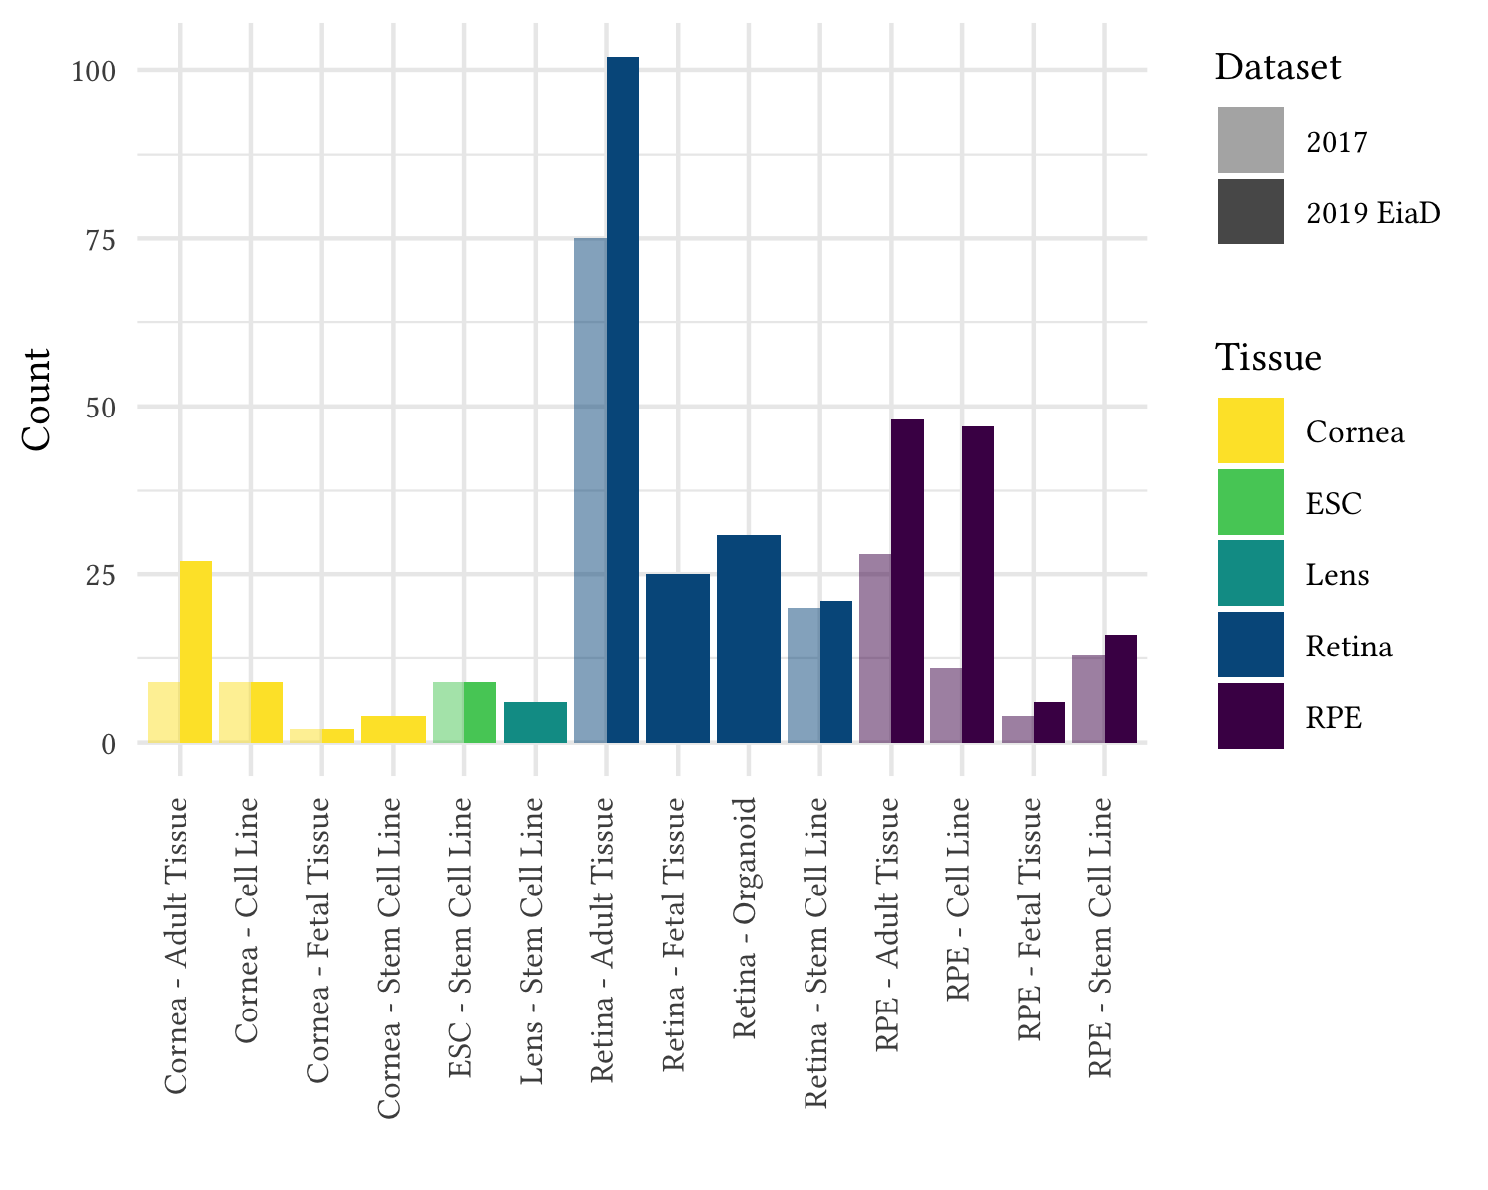

Figure 1: Substantial increase in eye tissue count and type from 2017 to 2019 EiaD

Our initial query to the SRA found 107 potentially relevant studies deposited since our last search on January 19, 2017. We removed non-pertinent studies and selected healthy or unmodified tissue from each relevant study for a total, including of 44 studies, 28 of which are new to the 2019 EiaD dataset. The 2019 EiaD dataset contains 387 human eye tissues and also includes 845 GTEx samples across 44 tissues for easy comparison Table 1, Supplemental Table 1. The 2019 EiaD contains 52 cornea, 6 lens, 179 retina, and 141 RPE (choroid) samples; in total we have added 207 new samples to the 2019 EiaD (Figure 1). Stem cell derived cornea, stem cell derived lens, fetal retina, and organoid retina are four new types of sub-tissues that are now available in eyeIntegration. Another substantial addition to the 2019 EiaD are non-protein coding genes. We now quantify expression across 42 gene types and 46 transcript types, including protein coding, retained intron, lincRNA, antisense, and pseuodgenes.

## Rigorous quality control and reproducible workflow system ensures high quality transcriptomes that consistently cluster together by tissue type

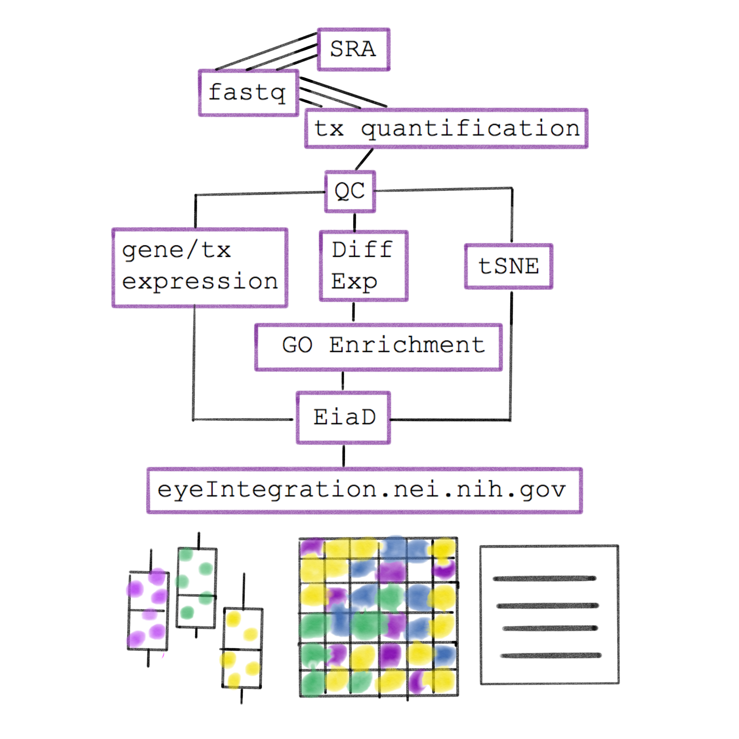

Figure 2: Raw RNA-seq data from the SRA is run through our pipeline to create the EiaD, which is used by eyeIntegration app to serve interactive gene expression visualizations across 60 tissues

We built an automated pipeline for processing and analyzing all data for the web app using the program Snakemake, a python-based workflow management system that allows for efficient parallel execution of the analysis, facilitates reproduction by others, and simplifies long term maintenance of the EiaD data (Figure 2, Supplemental Figure 1)53. In order to create a high quality final dataset across the 1311 initial samples (Supplemental Table 2) and 46,030,412,878 reads we developed a rigorous quality control procedure as part of our analysis, considering a sample’s read mapping rate and median count level as well as behavior relative to samples of the same sub-tissue type (see Methods). To identify tube switches or sample extraction issues, we used t-SNE to group samples by sub-tissue type to identify variability within samples of the same sub-tissue and ensure overall consistency in data processing (Figure 3).

After our quality control and processing workflow, we found that samples of the same tissue type and origin cluster well together (Figure 3). For example, in retina derived tissue, primary adult tissue clusters tightly and distinctly from other cell types, and retinal organoids and fetal retina tissue cluster together. Our ability to uniformly cluster data by known biological function independent of study origin demonstrates that our workflow can effectively account for technical variation between studies.

While t-SNE is a powerful algorithm for grouping samples, it is not consistent for determining the relationships between clusters56; PCA is more useful in this regards. We ran a PCA dimensionality reduction (Supplemental Figure 2) on all samples, finding that the eye tissues still generally group together and apart from the human body tissues. Adult retina is most similar to the brain tissue, pituitary is similar to adult RPE, and skin and blood are similar to cornea.

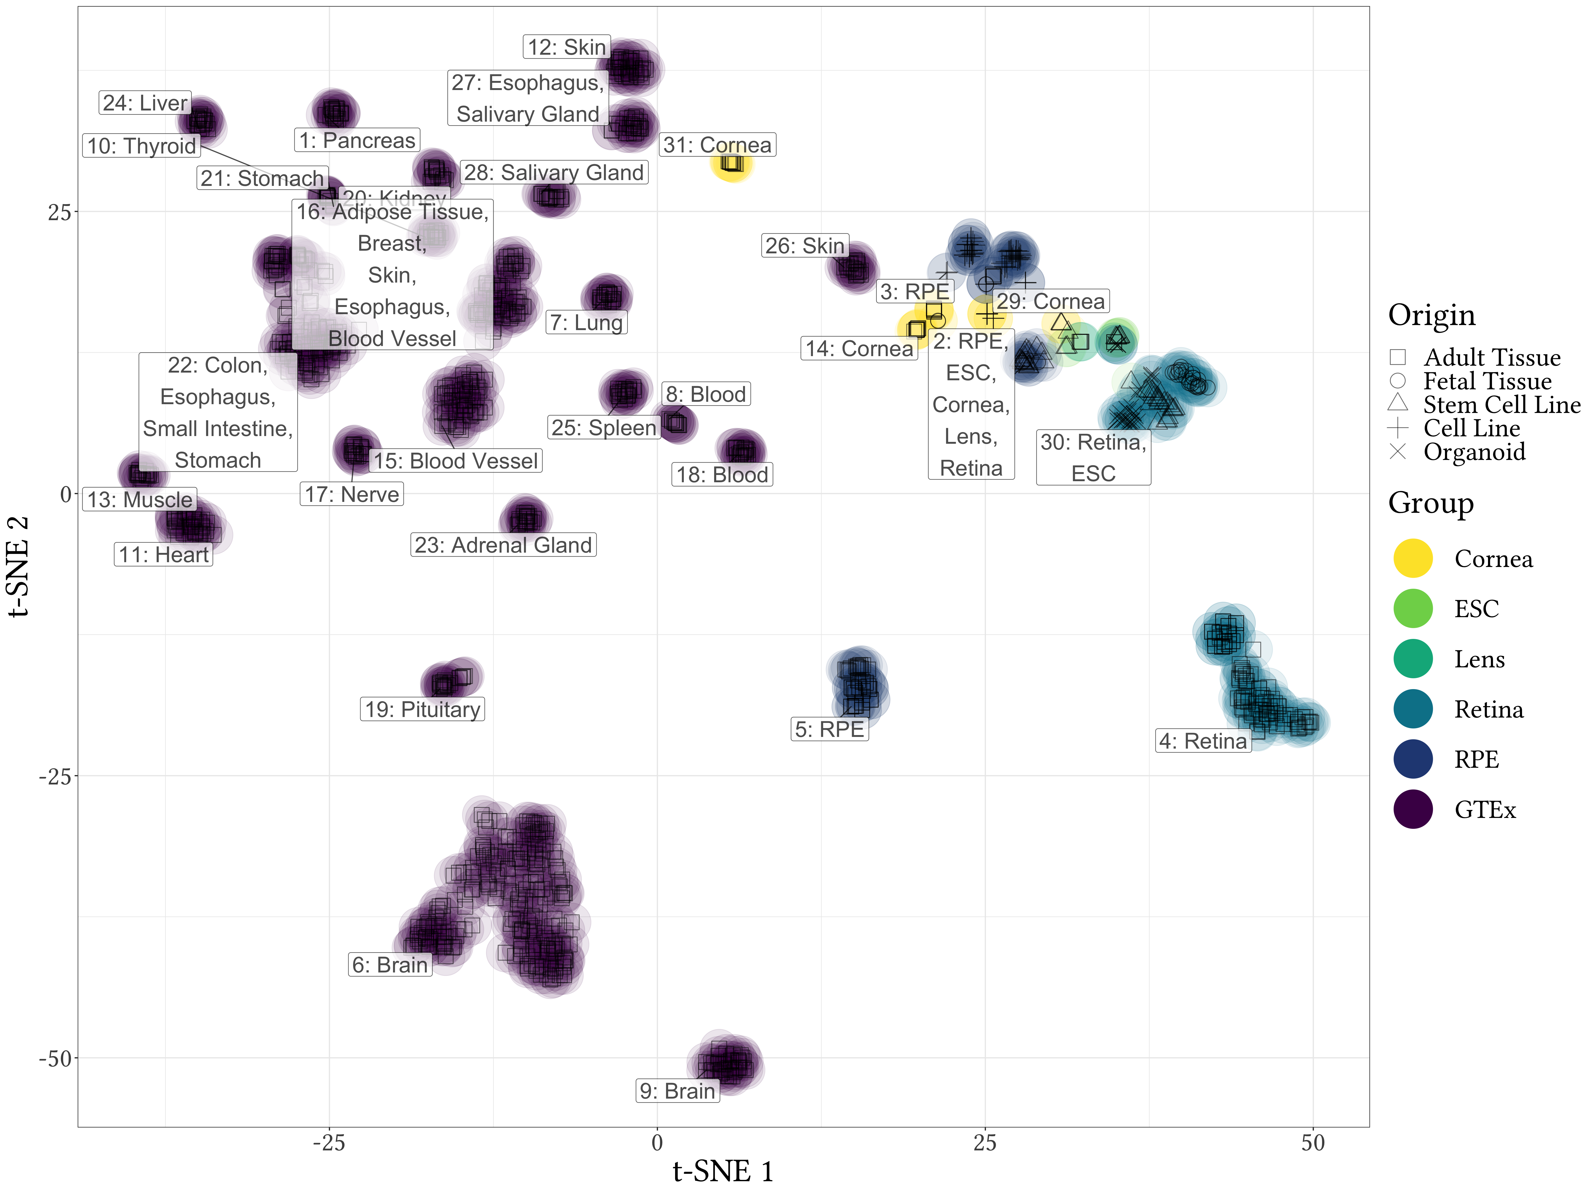

Figure 3: t-SNE tissue - tissue consistent two-dimensional sample - sample transcriptome profiles demonstrate effective quality control and sample processing. Colors match different tissue sets and shapes of points define the origin of the tissues.

| Tissue | Pre QC Count | Count | Sub-Tissue Types (Count) |
| --- | --- | --- | --- |
| Cornea | 62 | 42 | Adult Tissue (27), Cell Line (9), Fetal Tissue (2), Stem Cell Line (4) |
| Lens | 9 | 6 | Stem Cell Line (6) |
| Retina | 196 | 179 | Adult Tissue (102), Fetal Tissue (25), Organoid (31), Stem Cell Line (21) |
| RPE | 143 | 117 | Adult Tissue (48), Cell Line (47), Fetal Tissue (6), Stem Cell Line (16) |

*Table 1: EiaD contain a huge set of diverse eye tissues*

## eyeIntegration web app provides interactive visual portal to all data

The EiaD 2019 dataset is presented through the eyeIntegration web app (<https://eyeIntegration.nei.nih.gov>). The web app was designed to provide a simple interface that have the same general concept – select specific genes and tissue and view relevant information. The web-app is divided into four general categories: expression, two-dimension sample (or single cell) relationships, gene networks, and data tables.

## Custom gene and tissue expression boxplots

The expression tab of the webpage provides a wealth of information about both gene and transcript expression in a range of eye and body tissues, giving the user the ability to compare the expression of different genes within a single tissue, as well as the expression of genes across multiple tissues (Figure 4A). The user first selects either the 2017 or 2019 gene or transcript EiaD dataset, then genes (or transcripts), then tissues. A boxplot is then generated afer hitting the “Re(Draw) Plot” with overlaid individual data points. A tabular report is generated based on selected genes and tissues: a table with links to Ensembl, GeneCard, and OMIM for each gene for quick referencing, and a table containing expression levels for each selected gene in each selected tissue. The tables can be arranged or sorted to the user’s preference, and can be easily downloaded for local use.

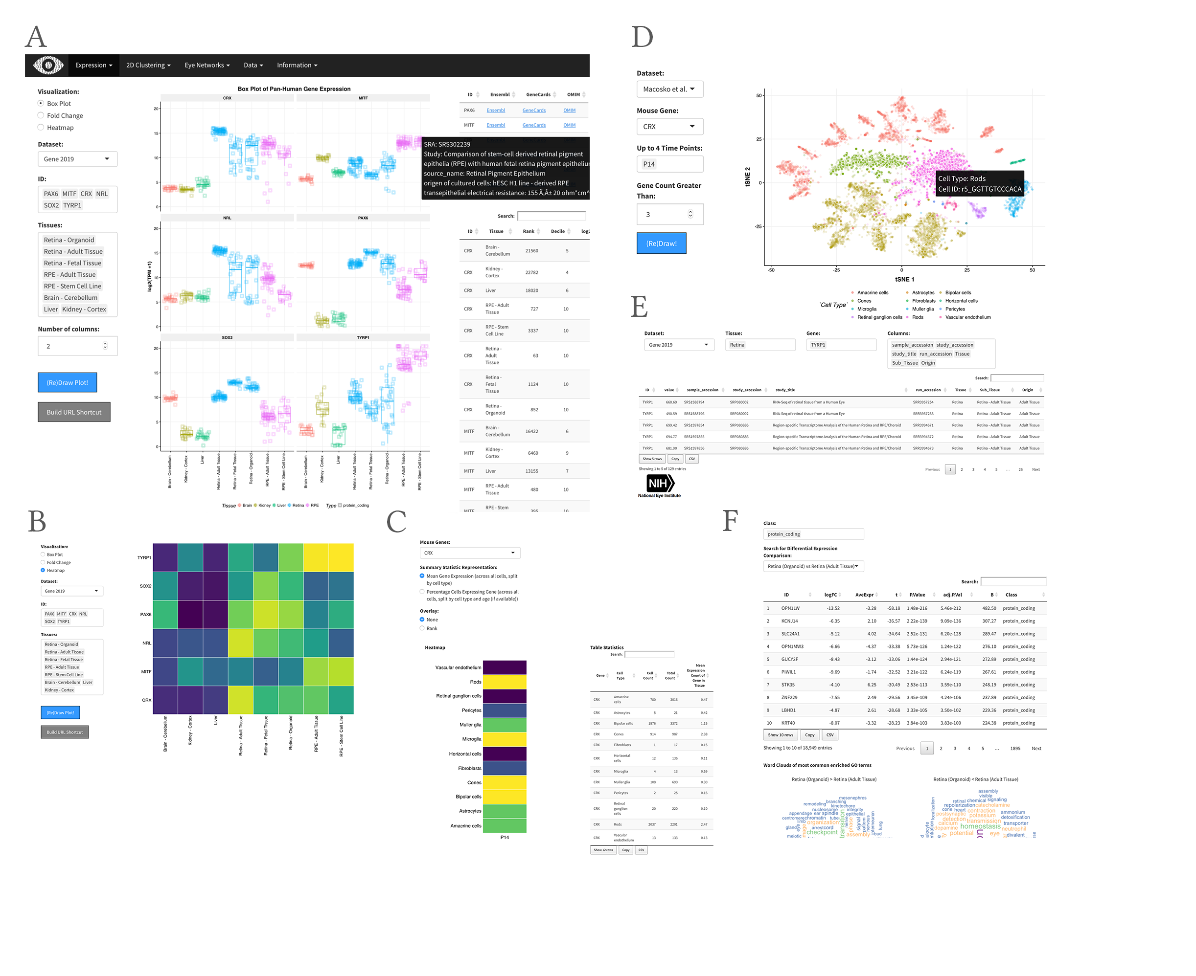

Figure 4: Various screenshots from eyeIntegration web app. A. Pan-tissue gene expression box plots with accompanying data tables. B. Alternative heatmap visualization. C. CRX gene expression heatmap and table information from Macosko et al. P14 scRNA-seq. D. t-SNE visualization of individual cell gene expression profiles from Macosko et al. E. Data table export view. F. Differential gene expression across different tissues and with GO term enrichment.

Heatmaps based on expression can be drawn for selected genes and tissues, and are useful for comparing gene expression across many genes and tissues (Figure 4B). Finally, a session can be saved or shared by building a custom link for the session with the “Build URL Shortcut” button.

## Differential expression and gene ontology enrichment tests allow quick comparison of gene differences between groups

Using our expression data, we performed multiple differential comparisons at the sub-tissue level within all eye tissues and against a pan-body synthetic set comprised of a stratified sample of all tissues present in the GTEx data set, allowing users to quickly identify eye specific genes across 105 different comparisons. The user can view the results under the ‘Differential’ selection under the ‘expression’ tab (Figure 4F). As with expression, the user can select which version of the web app to draw data from as well as select for gene or transcript level comparisons. The user additionally has the option to select different gene classes to examine, protein coding, lincRNA etc.

The results of differential expression are presented in a tabular format showing log2 fold change, average expression, and different statistical values. Depending on the comparison, there are 335 to 26281 differentially expressed genes (Supplemental Table 3). The table can be easily searched for any given gene, viewed and ordered to the user’s preference, and downloaded in CSV format. Differential expression can be visualized through fold change bar graphs in the ‘pan-tissue plots’ section under expression. Additionally, we performed GO enrichment for all differential comparisons. Enriched GO terms are presented first as a word cloud, for quick comparison of GO enrichment. We provide tables, with similar viewing options as the differential expression table, for enriched GO terms in each class of a given differential comparison.

## Murine scRNA-seq enables testing of retina cell type specific expression

We provide scRNA-seq data from murine retina across two studies54,55. This allows researchers to quickly examine gene expression across individual cell types in the retina. Single cell gene expression data is visualized through a heatmap showing the expression of a gene across multiple retinal cell types and different developmental time points (E11-P14, if available), and a table of expression values is generated containing the expression data used to draw the heatmap (Figure 4C). We also provide t-SNE/UMAP based clustering using cell type specific labeling created by the publishing authors (Figure 4D, see Methods). The plots show all cell types present a given developmental stage, and highlights cells expressing a gene above a user given level.

## EiaD 2019 demonstrates that organoids, iPSC-derived, and fetal tissue retina have closely related transcriptomes

There are, currently, three approaches to collecting human fetal retina: 1. post-mortem tissue, 2. organoids, and 3. iPSC-derived cells. As an example of how the EiaD 2019 dataset can be used to address pan-study questions, we looked at whether at how well these three approaches to generating developing retina compare at a transcriptomic level. Should organoid and iPSC-derived cell line retina compare closely to fetal tissue, this would further re-inforce the value of these approaches in studying human retina development.

To evaluate this question, we look at the same t-SNE plot from Figure 3 and focus in on the four types of retina tissue (adult, fetal, iSPC, and organoid) (Figure 5). Here we see three distinct groupings: adult retina (2), developing retina (3), and iPSC/undifferentiated (1). We do see several organoid tissues in cluster 1, but these share one important difference from the rest of the organoid samples in cluster 3: they have been differentiating for less than 30 days (shape ‘X’). All of the iPSC-based retina samples are older than 50 days.

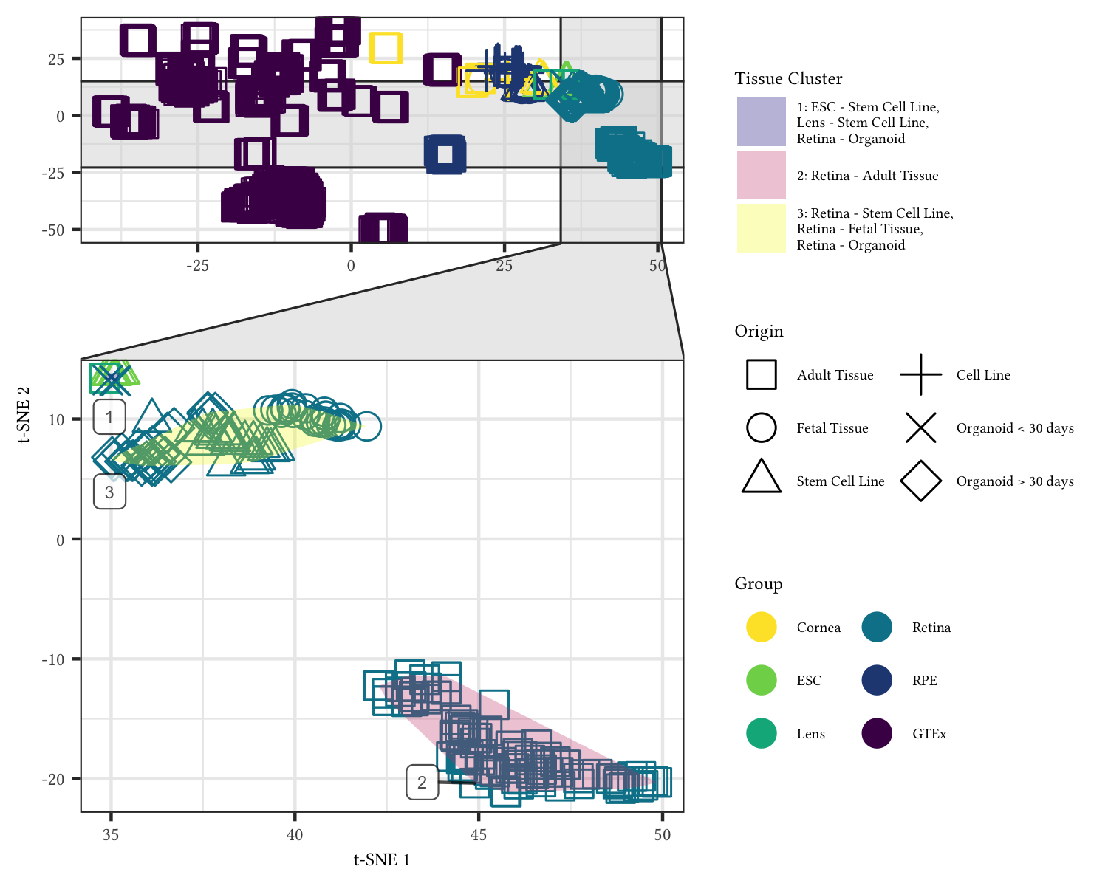

Figure 5: Organoid retina, iPSC retina, and fetal retina tissue have highly similar transcriptomes. The zoom inset shows the retina samples. The “Tissue Cluster” shading shows the cluster membership of the three major groups. The shapes of the points show the different origin types - notable types include the square for adult, the ‘X’ for organoid under 30 days of differentiation, and the diamond for organoid over 30 days of differentiation.

## Data accessibility

Individual data files for gene expression and sample metadata can be downloaded from the ‘Data’ tab on the web app. All data and code used to generate the web app can be installed from the R command line by running devtools::install_github(‘davidmcg/eyeIntegration_app’). Code for the EiaD data processing pipeline can be found at <https://github.com/davidmcg/Eyeintegration_autobuild>.

# Discussion

EiaD 2019 contains a large set of carefully curated, reproducibly processed human eye RNA-seq datasets alongside a crucial human body tissue comparison set from the GTEx project. It is available for local install as an R package at <https://www.github.com/davemcg/eyeIntegration_app> and is served via a powerful web app, eyeIntegration at <https://eyeIntegration.nei.nih.gov>. The web app offers a wide range of user-driven visualizations to compare expression of genes across dozens of human body and eye tissues. Furthermore, murine scRNA-seq datasets have been integrated, allowing for examination of retina cell type specific gene expression. Several human and non-human primate studies have been posted in the past year on the pre-print server bioRxiv and once the raw data becomes publicly available, we will be updating the section eyeIntegration57–59.

As human fetal tissue is extremely difficult to obtain and not amenable for chemical or genetic modification, it is crucial for iPSC and organoid based developmental methods to be developed. Our merging of these datasets and analysis at a transcriptome level (as compared to evaluating with a few marker genes) demonstrates that these two approaches are successfully recapitulating fetal tissues to a first approximation at the whole transcriptome level. This result underscores the value of these approaches in building models for human retina developmental.

Wrapping all of the data processing steps in a Snakemake pipeline has several important features: our code is publicly available for review, our analyses are reproducible, future sample updates can be streamlined in with minimal effort, and because all the processing is in modular pieces it is easier to add new analysis steps. In the future, we plan on regularly adding new samples to EiaD, offering *de novo* eye tissue transcriptomes, adding non-human eye samples, and epigenetic datasets.

# Supplementary Figures and Tables

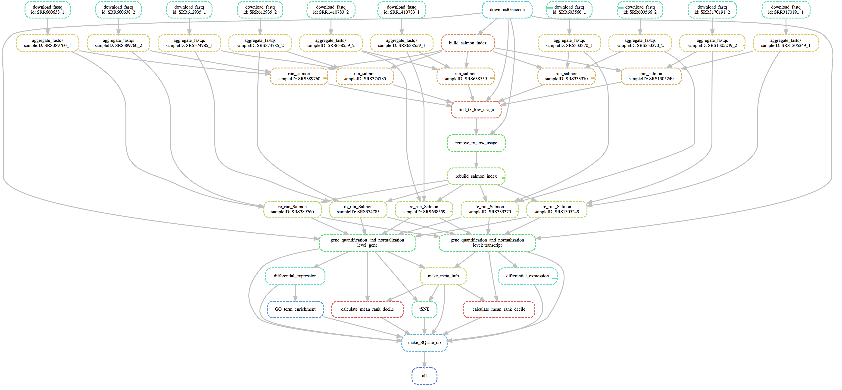

Supplemental Figure 1: Snakemake pipeline to create EiaD 2019 consists of small modular compute sections to ensure sample tracking through the full pipeline

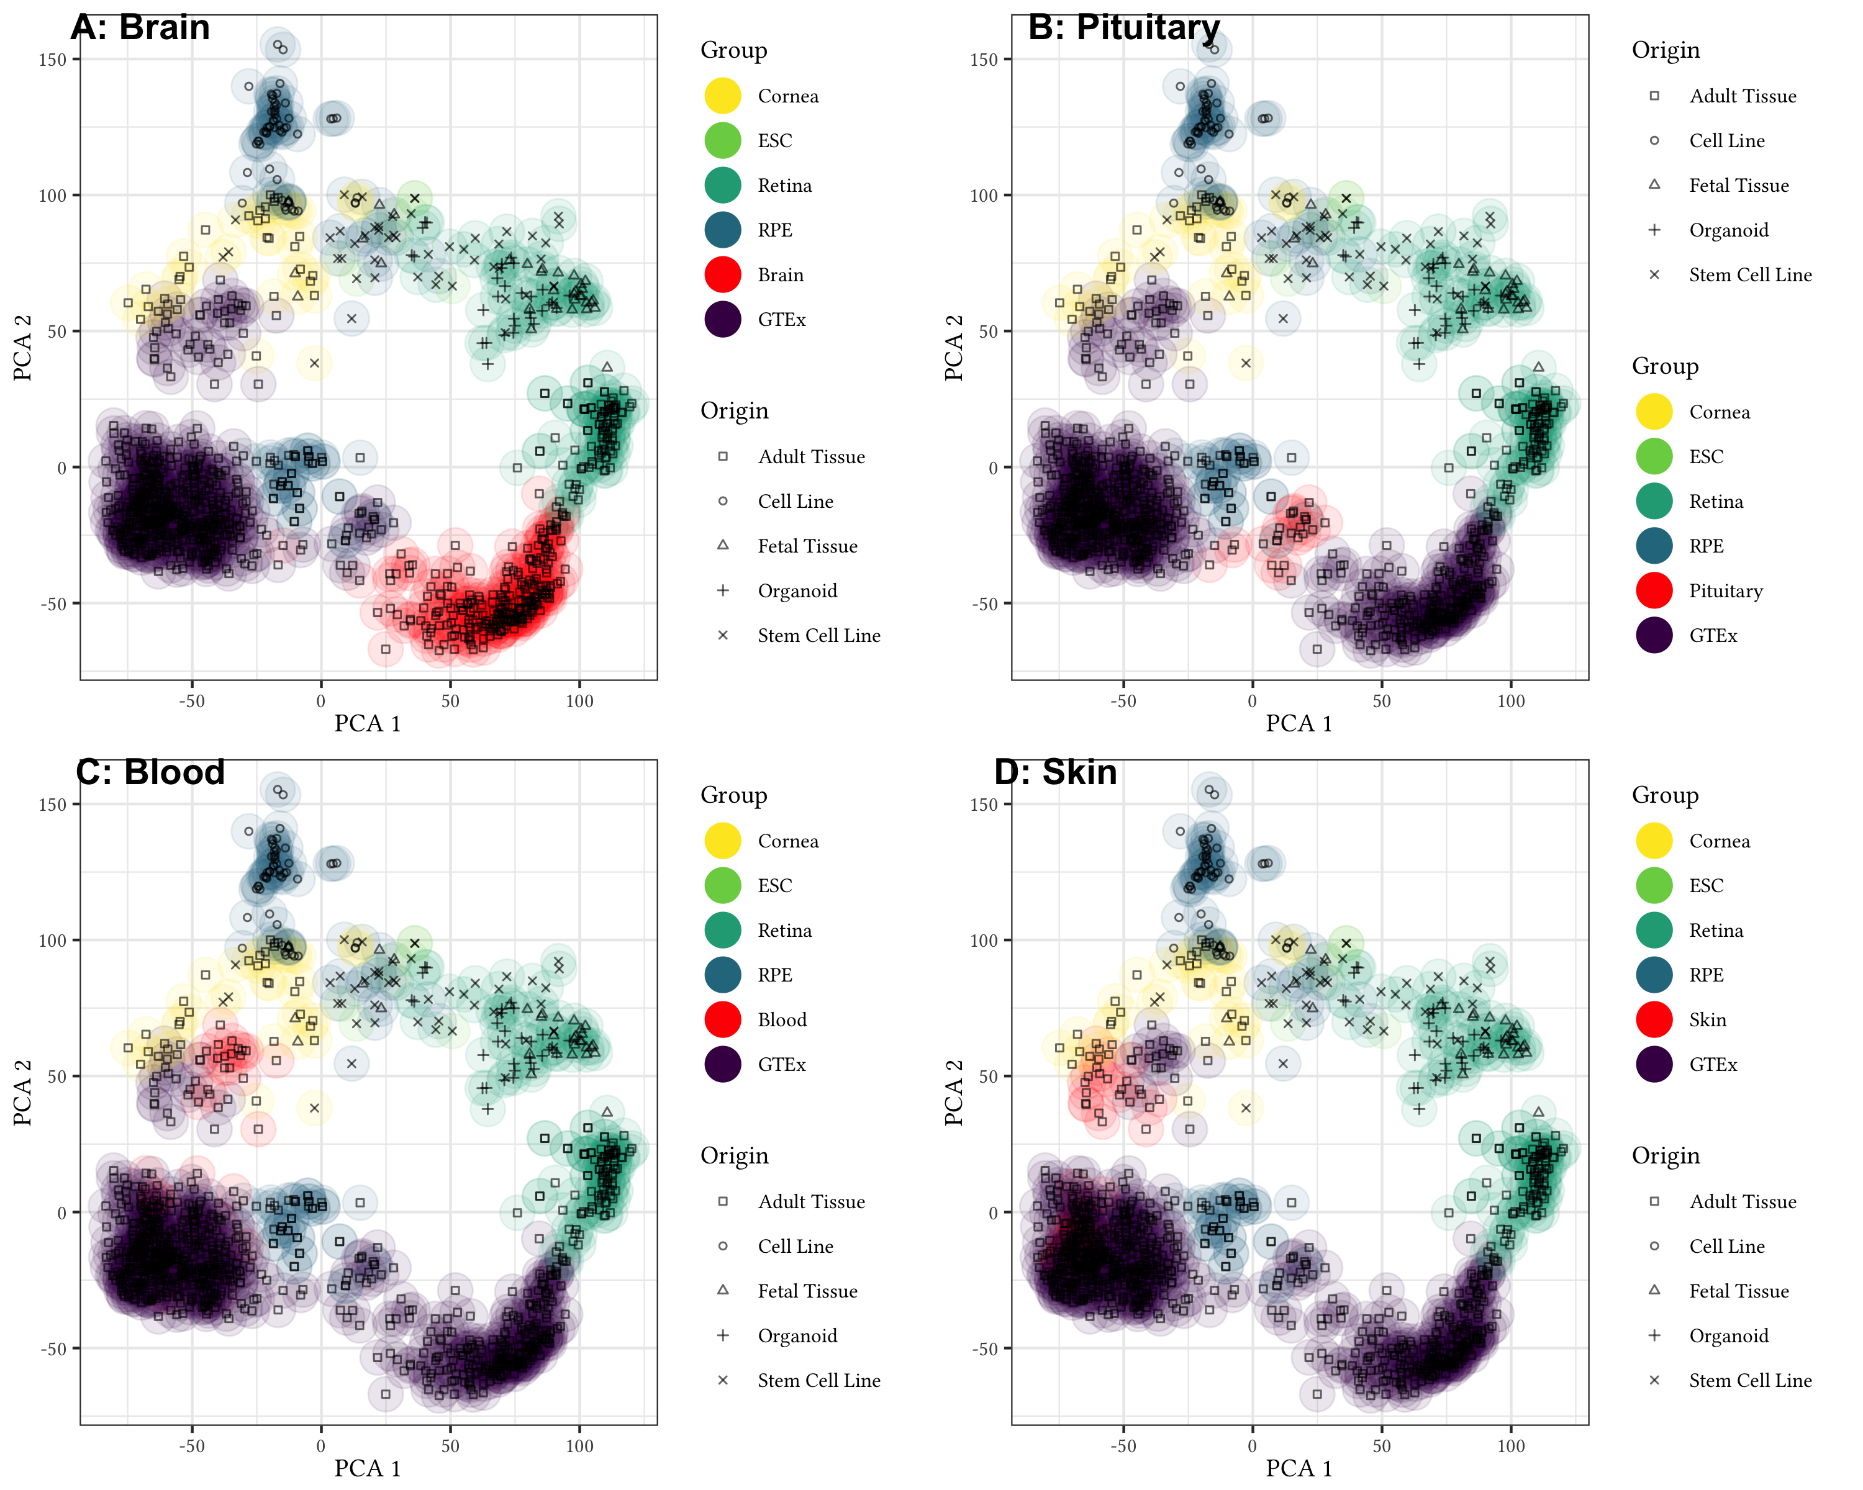

Supplemental Figure 2: PCA plot of all samples demonstrates non-eye tissue most similar to adult retina is the brain, pituitary most similar to adult RPE, and skin and blood similar to cornea.

##   
## Attaching package: 'maps'

## The following object is masked from 'package:purrr':  
##   
## map

## Warning: Ignoring unknown aesthetics: x, y

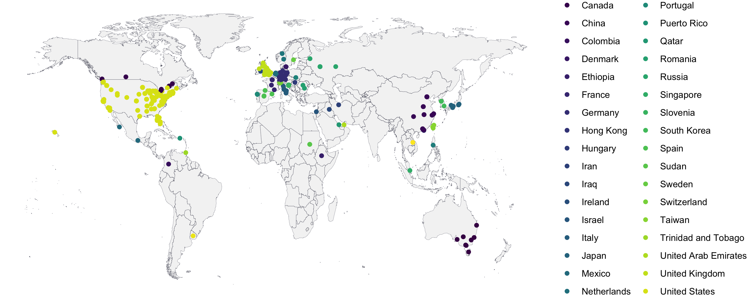

Supplemental Figure 3: As of January 2019, eyeIntegration has had usage across 285 cities and 40 countries.

| sample_accession | study_accession | study_title | study_abstract | sample_attribute | Tissue | Sub_Tissue | Origin | Kept |
| --- | --- | --- | --- | --- | --- | --- | --- | --- |
| SRS311709 | SRP012585 | Identification of miRNA signatures during the differentiation of hESCs into retinal pigment epithelial cells | Retinal pigment epithelium (RPE) cells can be obtained through in vitro differentiation of both embryonic stem cell (ESC) and induced pluripotent stem cells (iPSC) for cell replacement therapy. We have previously identified 87 signature genes relevant to RPE cell differentiation and function through transcriptome analysis of both human ESC- and iPSC-derived RPE as well as normal fetal RPE. Here, we profiled miRNA expression through small RNA-seq in human ESCs and their RPE derivatives. Much like conclusions drawn from our previous transcriptome analysis, we found that the overall miRNA landscape in RPE is distinct from ESCs and other differentiated somatic tissues. We also profiled miRNA expression during intermediate stages of RPE differentiation and identified unique subsets of miRNAs that are gradually up- or downregulated, suggesting dynamic regulation of these miRNAs is associated with the RPE differentiation process. Indeed, the down-regulation of a subset of miRNAs during RPE differentiation is associated with up-regulation of RPE-specific genes, such as RPE65, which is exclusively expressed in RPE. We conclude that miRNA signatures can be used to classify different degrees of in vitro differentiation of RPE from human pluripotent stem cells. We suggest that RPE-specific miRNAs likely contribute to the functional maturation of RPE in vitro, similar to the regulation of RPE-specific mRNA expression. Overall design: Study miRNA in ESC-derived RPE | source_name: fetal RPE || cell type: primary fetal RPE | RPE | RPE - Fetal Tissue | Fetal Tissue | low salmon mapping rate |
| SRS2445758 | SRP115908 | Spontaneous generation of a novel fetal human retinal pigment epithelium (RPE) cell line available for investigation on phagocytosis and morphogenesis | Purpose: Primary retinal pigment epithelium (RPE) cells have a limited capacity to re-establish epithelial morphology and to remain native RPE function in vitro, and all commercially available RPE cell lines have drawbacks of morphology or function; therefore, the establishment of new RPE cell lines with typical characteristics of RPE would be helpful in further understanding of their physiological and pathological mechanism. Here, we firstly report a new spontaneously generated RPE line, fhRPE-13A, from a 13-week aborted foetus. We aimed to investigate its availability as a RPE model. Methods:RNA-seq data were mapped to the human genome assembly hg19. Global transcriptional data were analyzed by Weighted Gene Co-expression Network Analysis (WGCNA) and differentially expressed genes(DEGs) to identify gene expression profiles. The morphology and molecular characteristics were examined by immunofluorescence, transmission electron micrographs, PCR and western blot. Photoreceptor outer segments (POS) phagocytosis assay and transepithelial resistance measurement (TER) were performed to assess phagocytic activity and barrier function, respectively. Results: The fhRPE-13A cells showed typical polygonal morphology and the normal biological processes of RPE, had ability of POS phagocytosis in vitro, and expressed TYR and TYRP1 significantly higher than that in ARPE-19 cells. Conclusions: The fetal human RPE line fhRPE-13A is a valuable system for researching phagocytosis function and morphogenesis of RPE in vitro. Overall design: mRNA profiles of RPE cell lines and passaged primary RPE at different stage were generated by deep sequencing using Illumina HiSeq2000. | source_name: primary ahRPE || cell type: retina pigment epithelium || passages: 4 || Stage: 4 days | RPE | RPE - Adult Tissue | Adult Tissue | Kept |
| SRS1478833 | SRP075990 | Directed differentiation of human embryonic stem cells to corneal endothelial cell-like cells: A transcriptomic analysis | The corneal endothelium is composed of a monolayer of corneal endothelial cells (CECs), which is essential for maintaining corneal transparency. Human embryonic stem cells (hESCs) hold the promise of providing an abundant donor source for generating CEC cells for cell replacement therapies. Here we demonstrate that CEC-like cells can be efficiently derived from human ESCs. In addition, we performed global gene expression profiling of stem-cell-derived CEC cells, incorporating with adult CEC cells, fetal CEC cells and other human tissue type data. Our data indicate that hESC-derived CEC-like cells closely resemble human fetal CEC cells. Overall design: We analyzed a total of 44 samples. 6 samples were sequenced by our group. High-throughput RNA-seq data from human ES cell-derived CEC-like cells samples (n=4) and cultured adult CEC samples (n=2) using Illumina HiSeq 2000. 38 samples are publicly available in GEO. The entire set of processed data is linked below as supplementary file 44_samples_RPKM.txt. | source_name: cultured adult CECs || cell type: cultured adult CECs || differentiation time: NA | Cornea | Cornea - Adult Tissue | Adult Tissue | Kept |
| SRS1305277 | SRP070148 | Transcriptome profiling of human keratoconus corneas through RNA sequencing identifies collagen synthesis disruption and downregulation of core elements of TGF-ÃƒÅ¸, Hippo, and Wnt pathways | To understand better the factors contributing to keratoconus (KTCN), we used RNA sequencing to perform a transcriptome profile of human KTCN corneas. Over 82% of the genes and almost 75% of the transcripts detected as differentially expressed in KTCN and non-KTCN corneas were confirmed in the replication study using another set of samples. We used these differentially expressed genes to generate a network of KTCN-deregulated genes. We found an extensive disruption of collagen synthesis and maturation pathways, as well as downregulation of the core elements of the TGF-ÃƒÅ¸, Hippo, and Wnt signaling pathways influencing corneal organization. We identified long noncoding RNAs (lncRNAs) and conducted a computational analysis of their potential functions, and found that lncRNAs regulated the processing and expression of the aforementioned genes. This first comprehensive transcriptome profiling of human KTCN corneas points further to a complex etiology of KTCN. Overall design: Transcription profiling of 25 KTCN and 25 non-KTCN corneas using RNA-Seq | source_name: Cornea || disease state: non-KTCN || study: discovery || tissue: cornea | Cornea | Cornea - Adult Tissue | Adult Tissue | low salmon mapping rate |
| SRS846886 | SRP055101 | Transcriptomic analysis of cultured corneal endothelial cells as a validation for their use in cell-replacement therapy | The corneal endothelium plays a primary role in maintaining corneal homeostasis and clarity, and must be surgically replaced with allogenic donor corneal endothelium in the event of visually significant dysfunction. However, a worldwide shortage of donor corneal tissue has led to a search for alternative sources of transplantable tissue. Cultured human corneal endothelial cells (HCEnC) have been shown to restore corneal clarity in experimental models of corneal endothelial dysfunction in animal models, but characterization of cultured HCEnC remains incomplete. To this end, we utilized next-generation RNA sequencing technology to compare the transcriptomic profile of ex vivo human corneal endothelium (evHCEnC) with that of primary HCEnC and HCEnC lines, and to determine the utility of cultured and immortalized corneal endothelial cells as models of in vivo corneal endothelium. Multidimensional analyses of the transcriptome datasets demonstrated that primary HCEnC have a closer relationship to evHCEnC than do immortalized HCEnC. Subsequent analyses showed that the majority of the genes specifically expressed in HCEnC (not expressed in ex vivo corneal epithelium or fibroblasts) demonstrated a marked variability of expression in cultured cells compared with evHCEnC. In addition, genes associated with either corneal endothelial cell function or corneal endothelial dystrophies were investigated. Significant differences in gene expression and protein levels were observed in the cultured cells compared with evHCEnC for each of the genes tested except for AGBL1 and LOXHD1, which were not detected by RNA-seq or qPCR. Our transcriptomic analysis suggests that at a molecular level primary HCEnC most closely resemble evHCEC and thus represent a viable therapeutic option for managing corneal endothelial dysfunction. Our findings also suggest that investigators should perform an assessment of the entire transcriptome of cultured HCEnC prior to determination of the potential clinical utility of the cultured HCEnC for the management of corneal endothelial cell failure. Overall design: Transcriptomes from ex vivo corneal endothelium, primary cultures and three cell lines were compared. Three samples of each endothelial cell group were submitted for RNA sequencing for a total of 15 samples. The transcriptome for the ex vivo corneal endothelium was used as the reference (i.e., proxy for in vivo corneal endothelium). Transcript abundances for a subset of genes associated with corneal endothelial cell function or disease were validated with qPCR and western blot. Samples of ex vivo endothelium used for validation were independent replicates not used for RNA-sequencing. | source_name: corneal endothelial cell line || cell type: endothelial || imortalization: SV40 TAg || culture medium: Human Endothelial-SFM | Cornea | Cornea - Cell Line | Cell Line | Kept |
| SRS2582152 | SRP119766 | Molecular anatomy of the developing human retina |  | D94-2 | Retina | Retina - Fetal Tissue | Fetal Tissue | Kept |
| SRS369431 | SRP016140 | Identification of Novel Molecular Markers through Transcriptomic Analysis in Human Fetal and Adult Corneal Endothelial Cells | Corneal endothelium is composed of a monolayer of corneal endothelial cells (CECs) in the inner layer of cornea, which is essential for maintaining corneal transparency. In order to better characterize CECs in different developmental stages, we profiled mRNA transcriptomes in human fetal and adult corneal endothelium with the goal to identify novel molecular markers in these cells. By comparing CECs with 12 other types of tissues, we identified 245 and 284 signature genes that are highly expressed in fetal and adult CECs, respectively. Functionally, these genes are characteristic of CECs, involving in cell adhesion, proteoglycan and sulfur metabolic process. Importantly, several of these genes are disease target genes in hereditary corneal dystrophies, consistent with their functional significance in CEC physiology. By comparing fetal and adult CECs, we also identified stage-specific markers associated with CEC maturation, such as the activation of the Wnt pathway genes in fetal, but not in adult CECs. Lastly, by immunohistochemistry of ocular tissues, we further confirmed the unique protein expression patterns for Wnt5a, S100A4, S100A6, and IER3, the four novel markers for either fetal or adult CECs. The identification of a new panel of molecular markers for fetal and mature CECs would be very useful for characterizing and quality controlling CECs through ex vivo expansion or stem cell differentiation for cell replacement therapy. Overall design: mRNA profile between adult and fetal CECs by high-throughput sequencing | source_name: corneal endothelial cells || cell type: corneal endothelial cells || age: 31y | Cornea | Cornea - Adult Tissue | Adult Tissue | Kept |
| E-MTAB-4377.RNA21 | E-MTAB-4377 | RNAseq 50 Normal Human Retina | RNA-seq of post-mort retina donor without clinically relevant visual impairment. Ploy-A enriched. 75-nt paired-end. Short time lapse between tissue sampling and cDNA generation. |  | Retina | Retina - Adult Tissue | Adult Tissue | Kept |
| SRS523838 | SRP034875 | Comprehensive Analysis of Gene Expression in Human Retina and Supporting Tissues | RNA-Seq of retina and RPE/choroid/sclera from 8 normal human eyes | tissue_type: Peripheral Retina_5 | Retina | Retina - Adult Tissue | Adult Tissue | Kept |
| SRS2511377 | SRP117613 | Treatment Paradigms for Retinal and Macular Diseases Using 3-D Retina Cultures Derived From Human Reporter Pluripotent Stem Cell Lines | We discuss the use of pluripotent stem cell lines carrying fluorescent reporters driven by retinal promoters to derive three-dimensional (3-D) retina in culture and how this system can be exploited for elucidating human retinal biology, creating disease models in a dish, and designing targeted drug screens for retinal and macular degeneration. Furthermore, we realize that stem cell investigations are labor-intensive and require extensive resources. To expedite scientific discovery by sharing of resources and to avoid duplication of efforts, we propose the formation of a Retinal Stem Cell Consortium. In the field of vision, such collaborative approaches have been enormously successful in elucidating genetic susceptibility associated with age-related macular degeneration. Overall design: CRX+ flow sorted cells from human retina derived organoids were collected at 6 time points during differentiation (day (D) 37, 48, 67, 90, 134, 220). | source_name: GFP positive neural retina cells || age: d48 || tissue: GFP positive neural retina cells || cell type: flow sorted CRXp-GFP positive cells at 48 days post neural retina induction | Retina | Retina - Stem Cell Line | Stem Cell Line | Kept |
| SRS1314621 | SRP070938 | Restoration of mesenchymal RPE by transcription factor-mediated reprogramming | TGFbeta-mediated epithelial-to-mesenchymal transition (EMT) is a major component of the wound healing response and a negative determinant of retinal pigment epithelial (RPE) differentiation after periods of sustained sub-confluent culture or repetitive passage. Inhibition of TGFbeta signaling using receptor kinase inhibitors forestalls the onset of passage-dependent EMT and can restore the capacity to differentiate to cells that previously underwent the mesenchymal switch [Radeke et al., 2015, Genome Med. 7:58]. However, even with the sustained inhibition of mesenchymal gene expression using TGFbeta signaling inhibitors the cells eventually lose the capacity to attain a characteristic phenotype. This suggests that there are additional mechanisms at play that contributeto the prevention of RPE differentiation after protracted periods of wound stimulus and mitosis. In this study we investigate the non-TGFbeta-mediated processes that contribute to the demise of the RPE phenotype after extended periods of proliferative wound response. Using comparative transcriptomics, we show that with increasing passage there is a downregulation of RPE genes, misregulation of cell cycle genes, a decline in proliferative potential that cannot be prevented or reversed by inhibition of TGFbeta signaling using the TGFbeta receptor kinase inhibitor A-83-01. Importantly, among the RPE genes with decreased expression are several transcription factors known to be critical for RPE development. Exogenous expression of MYCN and OTX2 in conjunction with A-83-01 treatment restored the ability of passage 7 RPE to differentiate. Taken together, these results demonstrate that the loss of capacity to differentiate as a result of chronic wound stimulus is a product of both TGFbeta pathway-dependent increases in mesenchymal gene expression and a TGFbeta pathway-independent loss of RPE programming. Overall design: PolyA+ RNA-Seq analysis of primary fetal RPE donor lines as a function of passage with and without treatment with A-83-01 or after transcription factor-mediated reprogramming were done in triplicate using cells obtained from different donors. PolyA+ RNA-Seq analysis of the adult RPE cell line ARPE-19 was carried out in triplicate using independent experimental replicates obtained on different days. In two instances the reads from duplicate sequencing runs were carried out on the same seqeuncing libraries and the sequence files were combined prior to analysis. | source_name: Fetal RPE-Donor "C" || donor id: hfRPE-081309 || plating density: 80,000 cells/cm2 || passage number: 4 || culture time: 32 Days || treatment: None || substrate: TC Plastic | RPE | RPE - Cell Line | Cell Line | Kept |
| SRS1837416 | SRP094572 | Expression data for hiPSC-derived RPE treated with 10mM Nicotinamide or vehicle | We did the RNA-seq analysis to examine the global impact of Nicotinamide (NAM) on hiPSC-derived RPE transcriptome in order to better understand the mechanism of action of NAM. NAM inhibited the expression of Age related Macular degeneration (AMD) associated protein transcripts in hiPSC-derived RPE. Overall design: Seven hiPSC-RPE lines (4 AMD donors and 3 Control donors) that had been cultured with 10mM NAM or vehicle for three weeks were used for RNA extraction and RNA-seq analysis. We treated 4 AMD hiPSC-RPE and 3 Control hiPSC-RPE lines with 10mM NAM or vehicle. | source_name: hiPSC-RPE 5 treated with vehicle for 3 weeks || gender: female || age: 91 || disease status: Control || treatment: Vehicle || tissue of origin: Cornea | Retina | Retina - Stem Cell Line | Stem Cell Line | outlier |
| SRS2582168 | SRP119766 | Molecular anatomy of the developing human retina |  | D73M | Retina | Retina - Fetal Tissue | Fetal Tissue | Kept |
| SRS897010 | SRP056957 | Transcriptome dynamics of developing photoreceptors in 3-D retina cultures recapitulates temporal sequence of human cone and rod differentiation revealing cell surface markers and gene networks | To define molecular mechanisms underlying rod and cone differentiation, we generated H9 human embryonic stem cell line carrying a GFP reporter that is controlled by the promoter of cone-rod homeobox (CRX) gene, the first known marker of post-mitotic photoreceptor precursors. CRXp-GFP reporter in H9 line replicates endogenous CRX expression when induced to form self-organizing 3-D retina-like tissue. We define temporal transcriptome dynamics of developing photoreceptors during the establishment of cone and rod cell fate. Our studies provide an essential framework for delineating molecules and cellular pathways that guide human photoreceptor development and should assist in chemical screening and cell-based therapies of retinal degeneration. Overall design: Undifferentiated CRXp-GFP HP hES cells and 3D-neural retina were collected at days 37, 47, 67 and 90 and dissociated into single cells. Cells were sorted at 4Ã‚Â°C and by FACSAria (Becton Dickinson). GFP+ and GFP- cells were separately collected. Total RNA was extracted by RNA purification kit (Norgen Biotek) and analyzed by 2100 Bioanalyzer (Agilent Technologies Genomics). High quality of total RNA (RIN: 7.7-9.2) was subjected to libraries construction using 40-60 ng of total RNA as input. Libraries were constructed using a stranded modification of the Illumina TruSeq mRNA (Brooks, et al. Meth Mol Biol 2012). Each library was single-end sequenced in an independent lane of a GAIIx at a length of 76 bases. Fastq files were generated from reads passing chastity filter. | source_name: hES derived neural retina || cell type: GFP positive neural retina cells || day post induction: Day 47 | Retina | Retina - Stem Cell Line | Stem Cell Line | Kept |
| SRS1597858 | SRP080886 | Region-specific Transcriptome Analysis of the Human Retina and RPE/Choroid | Proper spatial differentiation of retinal cell types is necessary for normal human vision. Many retinal diseases, such as Best disease and male germ cell associated kinase (MAK)-associated retinitis pigmentosa, preferentially affect distinct topographic regions of the retina. While much is known about the distribution of cell types in the retina, the distribution of molecular components across the posterior pole of the eye has not been well-studied. To investigate regional difference in molecular composition of ocular tissues, we assessed differential gene expression across the temporal, macular, and nasal retina and retinal pigment epithelium (RPE)/choroid of human eyes using RNA-Seq. RNA from temporal, macular, and nasal retina and RPE/choroid from four human donor eyes was extracted, poly-A selected, fragmented, and sequenced as 100 bp read pairs. Digital read files were mapped to the human genome and analyzed for differential expression using the Tuxedo... (for more see dbGaP study page.) | gap_accession: phs001151 || submitter handle: NEI_RetinaRPE_Choroid || biospecimen repository: NEI_RetinaRPE_Choroid || study name: Region-specific Transcriptome Analysis of the Human Retina and RPE/Choroid || study design: Control Set || biospecimen repository sample id: S5 || submitted sample id: S5 || submitted subject id: 1 || gap_sample_id: 1975645 || gap_subject_id: 1622642 || sex: female || body site: eye || histological type: RPE/choroid || analyte type: RNA || is tumor: No || subject is affected: No || molecular data type: RNA Seq (NGS) || gap_consent_code: 1 || gap_consent_short_name: GRU-NPU | RPE | RPE - Adult Tissue | Adult Tissue | Kept |
| SRS2445753 | SRP115908 | Spontaneous generation of a novel fetal human retinal pigment epithelium (RPE) cell line available for investigation on phagocytosis and morphogenesis | Purpose: Primary retinal pigment epithelium (RPE) cells have a limited capacity to re-establish epithelial morphology and to remain native RPE function in vitro, and all commercially available RPE cell lines have drawbacks of morphology or function; therefore, the establishment of new RPE cell lines with typical characteristics of RPE would be helpful in further understanding of their physiological and pathological mechanism. Here, we firstly report a new spontaneously generated RPE line, fhRPE-13A, from a 13-week aborted foetus. We aimed to investigate its availability as a RPE model. Methods:RNA-seq data were mapped to the human genome assembly hg19. Global transcriptional data were analyzed by Weighted Gene Co-expression Network Analysis (WGCNA) and differentially expressed genes(DEGs) to identify gene expression profiles. The morphology and molecular characteristics were examined by immunofluorescence, transmission electron micrographs, PCR and western blot. Photoreceptor outer segments (POS) phagocytosis assay and transepithelial resistance measurement (TER) were performed to assess phagocytic activity and barrier function, respectively. Results: The fhRPE-13A cells showed typical polygonal morphology and the normal biological processes of RPE, had ability of POS phagocytosis in vitro, and expressed TYR and TYRP1 significantly higher than that in ARPE-19 cells. Conclusions: The fetal human RPE line fhRPE-13A is a valuable system for researching phagocytosis function and morphogenesis of RPE in vitro. Overall design: mRNA profiles of RPE cell lines and passaged primary RPE at different stage were generated by deep sequencing using Illumina HiSeq2000. | source_name: fhRPE-13A cell line || cell line: fhRPE-13A || cell type: retina pigment epithelium || passages: 48 || Stage: 3 days | RPE | RPE - Cell Line | Cell Line | Kept |
| SRS897008 | SRP056957 | Transcriptome dynamics of developing photoreceptors in 3-D retina cultures recapitulates temporal sequence of human cone and rod differentiation revealing cell surface markers and gene networks | To define molecular mechanisms underlying rod and cone differentiation, we generated H9 human embryonic stem cell line carrying a GFP reporter that is controlled by the promoter of cone-rod homeobox (CRX) gene, the first known marker of post-mitotic photoreceptor precursors. CRXp-GFP reporter in H9 line replicates endogenous CRX expression when induced to form self-organizing 3-D retina-like tissue. We define temporal transcriptome dynamics of developing photoreceptors during the establishment of cone and rod cell fate. Our studies provide an essential framework for delineating molecules and cellular pathways that guide human photoreceptor development and should assist in chemical screening and cell-based therapies of retinal degeneration. Overall design: Undifferentiated CRXp-GFP HP hES cells and 3D-neural retina were collected at days 37, 47, 67 and 90 and dissociated into single cells. Cells were sorted at 4Ã‚Â°C and by FACSAria (Becton Dickinson). GFP+ and GFP- cells were separately collected. Total RNA was extracted by RNA purification kit (Norgen Biotek) and analyzed by 2100 Bioanalyzer (Agilent Technologies Genomics). High quality of total RNA (RIN: 7.7-9.2) was subjected to libraries construction using 40-60 ng of total RNA as input. Libraries were constructed using a stranded modification of the Illumina TruSeq mRNA (Brooks, et al. Meth Mol Biol 2012). Each library was single-end sequenced in an independent lane of a GAIIx at a length of 76 bases. Fastq files were generated from reads passing chastity filter. | source_name: hES derived neural retina || cell type: GFP positive neural retina cells || day post induction: Day 47 | Retina | Retina - Stem Cell Line | Stem Cell Line | Kept |
| SRS2445744 | SRP115908 | Spontaneous generation of a novel fetal human retinal pigment epithelium (RPE) cell line available for investigation on phagocytosis and morphogenesis | Purpose: Primary retinal pigment epithelium (RPE) cells have a limited capacity to re-establish epithelial morphology and to remain native RPE function in vitro, and all commercially available RPE cell lines have drawbacks of morphology or function; therefore, the establishment of new RPE cell lines with typical characteristics of RPE would be helpful in further understanding of their physiological and pathological mechanism. Here, we firstly report a new spontaneously generated RPE line, fhRPE-13A, from a 13-week aborted foetus. We aimed to investigate its availability as a RPE model. Methods:RNA-seq data were mapped to the human genome assembly hg19. Global transcriptional data were analyzed by Weighted Gene Co-expression Network Analysis (WGCNA) and differentially expressed genes(DEGs) to identify gene expression profiles. The morphology and molecular characteristics were examined by immunofluorescence, transmission electron micrographs, PCR and western blot. Photoreceptor outer segments (POS) phagocytosis assay and transepithelial resistance measurement (TER) were performed to assess phagocytic activity and barrier function, respectively. Results: The fhRPE-13A cells showed typical polygonal morphology and the normal biological processes of RPE, had ability of POS phagocytosis in vitro, and expressed TYR and TYRP1 significantly higher than that in ARPE-19 cells. Conclusions: The fetal human RPE line fhRPE-13A is a valuable system for researching phagocytosis function and morphogenesis of RPE in vitro. Overall design: mRNA profiles of RPE cell lines and passaged primary RPE at different stage were generated by deep sequencing using Illumina HiSeq2000. | source_name: fhRPE-13A cell line || cell line: fhRPE-13A || cell type: retina pigment epithelium || passages: 15 || Stage: 2 days | RPE | RPE - Cell Line | Cell Line | Kept |
| SRS896997 | SRP056957 | Transcriptome dynamics of developing photoreceptors in 3-D retina cultures recapitulates temporal sequence of human cone and rod differentiation revealing cell surface markers and gene networks | To define molecular mechanisms underlying rod and cone differentiation, we generated H9 human embryonic stem cell line carrying a GFP reporter that is controlled by the promoter of cone-rod homeobox (CRX) gene, the first known marker of post-mitotic photoreceptor precursors. CRXp-GFP reporter in H9 line replicates endogenous CRX expression when induced to form self-organizing 3-D retina-like tissue. We define temporal transcriptome dynamics of developing photoreceptors during the establishment of cone and rod cell fate. Our studies provide an essential framework for delineating molecules and cellular pathways that guide human photoreceptor development and should assist in chemical screening and cell-based therapies of retinal degeneration. Overall design: Undifferentiated CRXp-GFP HP hES cells and 3D-neural retina were collected at days 37, 47, 67 and 90 and dissociated into single cells. Cells were sorted at 4Ã‚Â°C and by FACSAria (Becton Dickinson). GFP+ and GFP- cells were separately collected. Total RNA was extracted by RNA purification kit (Norgen Biotek) and analyzed by 2100 Bioanalyzer (Agilent Technologies Genomics). High quality of total RNA (RIN: 7.7-9.2) was subjected to libraries construction using 40-60 ng of total RNA as input. Libraries were constructed using a stranded modification of the Illumina TruSeq mRNA (Brooks, et al. Meth Mol Biol 2012). Each library was single-end sequenced in an independent lane of a GAIIx at a length of 76 bases. Fastq files were generated from reads passing chastity filter. | source_name: hES derived neural retina || cell type: GFP negative neural retina cells || day post induction: Day 47 | Retina | Retina - Stem Cell Line | Stem Cell Line | Kept |
| SRS1314629 | SRP070938 | Restoration of mesenchymal RPE by transcription factor-mediated reprogramming | TGFbeta-mediated epithelial-to-mesenchymal transition (EMT) is a major component of the wound healing response and a negative determinant of retinal pigment epithelial (RPE) differentiation after periods of sustained sub-confluent culture or repetitive passage. Inhibition of TGFbeta signaling using receptor kinase inhibitors forestalls the onset of passage-dependent EMT and can restore the capacity to differentiate to cells that previously underwent the mesenchymal switch [Radeke et al., 2015, Genome Med. 7:58]. However, even with the sustained inhibition of mesenchymal gene expression using TGFbeta signaling inhibitors the cells eventually lose the capacity to attain a characteristic phenotype. This suggests that there are additional mechanisms at play that contributeto the prevention of RPE differentiation after protracted periods of wound stimulus and mitosis. In this study we investigate the non-TGFbeta-mediated processes that contribute to the demise of the RPE phenotype after extended periods of proliferative wound response. Using comparative transcriptomics, we show that with increasing passage there is a downregulation of RPE genes, misregulation of cell cycle genes, a decline in proliferative potential that cannot be prevented or reversed by inhibition of TGFbeta signaling using the TGFbeta receptor kinase inhibitor A-83-01. Importantly, among the RPE genes with decreased expression are several transcription factors known to be critical for RPE development. Exogenous expression of MYCN and OTX2 in conjunction with A-83-01 treatment restored the ability of passage 7 RPE to differentiate. Taken together, these results demonstrate that the loss of capacity to differentiate as a result of chronic wound stimulus is a product of both TGFbeta pathway-dependent increases in mesenchymal gene expression and a TGFbeta pathway-independent loss of RPE programming. Overall design: PolyA+ RNA-Seq analysis of primary fetal RPE donor lines as a function of passage with and without treatment with A-83-01 or after transcription factor-mediated reprogramming were done in triplicate using cells obtained from different donors. PolyA+ RNA-Seq analysis of the adult RPE cell line ARPE-19 was carried out in triplicate using independent experimental replicates obtained on different days. In two instances the reads from duplicate sequencing runs were carried out on the same seqeuncing libraries and the sequence files were combined prior to analysis. | source_name: Fetal RPE-Donor "B" || donor id: hfRPE-071709 || plating density: 80,000 cells/cm2 || passage number: 0 || culture time: 32 Days || treatment: None || substrate: Microporous support | RPE | RPE - Cell Line | Cell Line | removed |

*Supplemental Table 2: Full metadata for 20 random eye samples. Full metadata available as supplementary file.*

| Group | Pre QC Count | Count | Tissue Types (Count) |
| --- | --- | --- | --- |
| GTEx | 878 | 831 | Adipose Tissue (37), Adrenal Gland (20), Blood (32), Blood Vessel (56), Brain (245), Breast (20), Colon (40), Esophagus (60), Heart (37), Kidney (17), Liver (20), Lung (19), Muscle (17), Nerve (18), Pancreas (20), Pituitary (20), Salivary Gland (20), Skin (56), Small Intestine (20), Spleen (20), Stomach (20), Thyroid (17) |

*Supplemental Table 1: EiaD holds hundreds of GTEx tissues to provide a broad comparison set*

| Comparison | Count |
| --- | --- |
| Body_vs_Cornea_Adult.Tissue | 22467 |
| Body_vs_Cornea_Cell.Line | 17725 |
| Body_vs_Cornea_Fetal.Tissue | 3720 |
| Body_vs_Cornea_Stem.Cell.Line | 7699 |
| Body_vs_ESC_Stem.Cell.Line | 17067 |
| Body_vs_Lens_Stem.Cell.Line | 11713 |
| Body_vs_RPE_Adult.Tissue | 23898 |
| Body_vs_RPE_Cell.Line | 25470 |
| Body_vs_RPE_Fetal.Tissue | 11418 |
| Body_vs_RPE_Stem.Cell.Line | 19450 |
| Body_vs_Retina_Adult.Tissue | 26281 |
| Body_vs_Retina_Fetal.Tissue | 23943 |
| Body_vs_Retina_Organoid | 25714 |
| Body_vs_Retina_Stem.Cell.Line | 24006 |
| Cornea_Adult.Tissue_vs_ESC_Stem.Cell.Line | 11287 |
| Cornea_Adult.Tissue_vs_RPE_Adult.Tissue | 19749 |
| Cornea_Adult.Tissue_vs_RPE_Cell.Line | 14321 |
| Cornea_Adult.Tissue_vs_RPE_Fetal.Tissue | 5771 |
| Cornea_Adult.Tissue_vs_RPE_Stem.Cell.Line | 13729 |
| Cornea_Adult.Tissue_vs_Retina_Adult.Tissue | 21402 |
| Cornea_Cell.Line_vs_Cornea_Adult.Tissue | 12949 |
| Cornea_Cell.Line_vs_Cornea_Fetal.Tissue | 3811 |
| Cornea_Cell.Line_vs_ESC_Stem.Cell.Line | 10135 |
| Cornea_Cell.Line_vs_RPE_Adult.Tissue | 15049 |
| Cornea_Cell.Line_vs_RPE_Cell.Line | 11297 |
| Cornea_Cell.Line_vs_RPE_Fetal.Tissue | 7069 |
| Cornea_Cell.Line_vs_RPE_Stem.Cell.Line | 12199 |
| Cornea_Cell.Line_vs_Retina_Adult.Tissue | 17723 |
| Cornea_Fetal.Tissue_vs_Cornea_Adult.Tissue | 2952 |
| Cornea_Fetal.Tissue_vs_ESC_Stem.Cell.Line | 4170 |
| Cornea_Fetal.Tissue_vs_RPE_Adult.Tissue | 4950 |
| Cornea_Fetal.Tissue_vs_RPE_Cell.Line | 3554 |
| Cornea_Fetal.Tissue_vs_RPE_Fetal.Tissue | 1182 |
| Cornea_Fetal.Tissue_vs_RPE_Stem.Cell.Line | 1993 |
| Cornea_Fetal.Tissue_vs_Retina_Adult.Tissue | 7073 |
| Cornea_Stem.Cell.Line_vs_Cornea_Adult.Tissue | 6318 |
| Cornea_Stem.Cell.Line_vs_Cornea_Cell.Line | 6387 |
| Cornea_Stem.Cell.Line_vs_Cornea_Fetal.Tissue | 1035 |
| Cornea_Stem.Cell.Line_vs_ESC_Stem.Cell.Line | 5917 |
| Cornea_Stem.Cell.Line_vs_RPE_Adult.Tissue | 9605 |
| Cornea_Stem.Cell.Line_vs_RPE_Cell.Line | 5985 |
| Cornea_Stem.Cell.Line_vs_RPE_Fetal.Tissue | 2488 |
| Cornea_Stem.Cell.Line_vs_RPE_Stem.Cell.Line | 3584 |
| Cornea_Stem.Cell.Line_vs_Retina_Adult.Tissue | 12449 |
| Cornea_Stem.Cell.Line_vs_Retina_Fetal.Tissue | 10866 |
| Cornea_Stem.Cell.Line_vs_Retina_Stem.Cell.Line | 8667 |
| ESC_Stem.Cell.Line_vs_RPE_Cell.Line | 11479 |
| ESC_Stem.Cell.Line_vs_RPE_Stem.Cell.Line | 11043 |
| Lens_Stem.Cell.Line_vs_Cornea_Adult.Tissue | 12022 |
| Lens_Stem.Cell.Line_vs_Cornea_Cell.Line | 10628 |
| Lens_Stem.Cell.Line_vs_Cornea_Fetal.Tissue | 3657 |
| Lens_Stem.Cell.Line_vs_Cornea_Stem.Cell.Line | 3943 |
| Lens_Stem.Cell.Line_vs_ESC_Stem.Cell.Line | 4236 |
| Lens_Stem.Cell.Line_vs_RPE_Adult.Tissue | 14659 |
| Lens_Stem.Cell.Line_vs_RPE_Cell.Line | 10841 |
| Lens_Stem.Cell.Line_vs_RPE_Fetal.Tissue | 5825 |
| Lens_Stem.Cell.Line_vs_RPE_Stem.Cell.Line | 9069 |
| Lens_Stem.Cell.Line_vs_Retina_Adult.Tissue | 13950 |
| Lens_Stem.Cell.Line_vs_Retina_Fetal.Tissue | 9562 |
| Lens_Stem.Cell.Line_vs_Retina_Stem.Cell.Line | 9253 |
| RPE_Adult.Tissue_vs_ESC_Stem.Cell.Line | 14897 |
| RPE_Adult.Tissue_vs_RPE_Cell.Line | 22411 |
| RPE_Adult.Tissue_vs_RPE_Stem.Cell.Line | 17274 |
| RPE_Adult.Tissue_vs_Retina_Adult.Tissue | 21368 |
| RPE_Cell.Line_vs_RPE_Stem.Cell.Line | 12739 |
| RPE_Fetal.Tissue_vs_ESC_Stem.Cell.Line | 6313 |
| RPE_Fetal.Tissue_vs_RPE_Adult.Tissue | 9070 |
| RPE_Fetal.Tissue_vs_RPE_Cell.Line | 4621 |
| RPE_Fetal.Tissue_vs_RPE_Stem.Cell.Line | 335 |
| RPE_Fetal.Tissue_vs_Retina_Adult.Tissue | 11954 |
| Retina_Adult.Tissue_vs_ESC_Stem.Cell.Line | 15081 |
| Retina_Adult.Tissue_vs_RPE_Cell.Line | 24475 |
| Retina_Adult.Tissue_vs_RPE_Stem.Cell.Line | 19166 |
| Retina_Fetal.Tissue_vs_Cornea_Adult.Tissue | 20544 |
| Retina_Fetal.Tissue_vs_Cornea_Cell.Line | 15700 |
| Retina_Fetal.Tissue_vs_Cornea_Fetal.Tissue | 5415 |
| Retina_Fetal.Tissue_vs_ESC_Stem.Cell.Line | 11474 |
| Retina_Fetal.Tissue_vs_RPE_Adult.Tissue | 21657 |
| Retina_Fetal.Tissue_vs_RPE_Cell.Line | 21735 |
| Retina_Fetal.Tissue_vs_RPE_Fetal.Tissue | 11362 |
| Retina_Fetal.Tissue_vs_RPE_Stem.Cell.Line | 18665 |
| Retina_Fetal.Tissue_vs_Retina_Adult.Tissue | 17373 |
| Retina_Fetal.Tissue_vs_Retina_Stem.Cell.Line | 12840 |
| Retina_Organoid_vs_Cornea_Adult.Tissue | 20540 |
| Retina_Organoid_vs_Cornea_Cell.Line | 16529 |
| Retina_Organoid_vs_Cornea_Fetal.Tissue | 3904 |
| Retina_Organoid_vs_Cornea_Stem.Cell.Line | 7624 |
| Retina_Organoid_vs_ESC_Stem.Cell.Line | 10008 |
| Retina_Organoid_vs_Lens_Stem.Cell.Line | 8618 |
| Retina_Organoid_vs_RPE_Adult.Tissue | 24070 |
| Retina_Organoid_vs_RPE_Cell.Line | 22524 |
| Retina_Organoid_vs_RPE_Fetal.Tissue | 9024 |
| Retina_Organoid_vs_RPE_Stem.Cell.Line | 16011 |
| Retina_Organoid_vs_Retina_Adult.Tissue | 20178 |
| Retina_Organoid_vs_Retina_Fetal.Tissue | 10634 |
| Retina_Organoid_vs_Retina_Stem.Cell.Line | 9977 |
| Retina_Stem.Cell.Line_vs_Cornea_Adult.Tissue | 19809 |
| Retina_Stem.Cell.Line_vs_Cornea_Cell.Line | 16972 |
| Retina_Stem.Cell.Line_vs_Cornea_Fetal.Tissue | 5220 |
| Retina_Stem.Cell.Line_vs_ESC_Stem.Cell.Line | 9990 |
| Retina_Stem.Cell.Line_vs_RPE_Adult.Tissue | 23101 |
| Retina_Stem.Cell.Line_vs_RPE_Cell.Line | 21146 |
| Retina_Stem.Cell.Line_vs_RPE_Fetal.Tissue | 9314 |
| Retina_Stem.Cell.Line_vs_RPE_Stem.Cell.Line | 15152 |
| Retina_Stem.Cell.Line_vs_Retina_Adult.Tissue | 19754 |

*Supplemental Table 3: Thousands of differentially expressed genes found (q < 0.01) for the 105 comparisons we ran.*

# Acknowledgements

We would like the thank the dozens of groups who provided the raw data required to create this project. We are keeping a running list of the projects and citations at <https://github.com/davemcg/eyeIntegration_app/blob/master/inst/citations.md> and strongly encourage anyone who uses EiaD and eyeIntegration to cite relevant projects. We would also like to thank Kapil Bharti, Robert Hufnagel, and Brian Brooks for their continuous set of critiques and suggestions of the eyeIntegration app over the past two years. This work utilized the computational resources and of the NIH HPC Biowulf cluster (<http://hpc.nih.gov>).

# Bibliography

1. Chen Y, Huang K, Nakatsu MN, Xue Z, Deng SX, Fan G. Identification of novel molecular markers through transcriptomic analysis in human fetal and adult corneal endothelial cells. *Hum Mol Genet*. 2013;22(7):1271-1279. doi:[10.1093/hmg/dds527](https://doi.org/10.1093/hmg/dds527)

2. Chng Z, Peh GSL, Herath WB, et al. High Throughput Gene Expression Analysis Identifies Reliable Expression Markers of Human Corneal Endothelial Cells. *PLOS ONE*. 2013;8(7):e67546. doi:[10.1371/journal.pone.0067546](https://doi.org/10.1371/journal.pone.0067546)

3. Chung DD, Frausto RF, Lin BR, Hanser EM, Cohen Z, Aldave AJ. Transcriptomic Profiling of Posterior Polymorphous Corneal Dystrophy. *Invest Ophthalmol Vis Sci*. 2017;58(7):3202-3214. doi:[10.1167/iovs.17-21423](https://doi.org/10.1167/iovs.17-21423)

4. Frausto RF, Le DJ, Aldave AJ. Transcriptomic Analysis of Cultured Corneal Endothelial Cells as a Validation for Their Use in Cell Replacement Therapy. *Cell Transplant*. 2016;25(6):1159-1176. doi:[10.3727/096368915X688948](https://doi.org/10.3727/096368915X688948)

5. Kabza M, Karolak JA, Rydzanicz M, et al. Collagen synthesis disruption and downregulation of core elements of TGF-*β*, Hippo, and Wnt pathways in keratoconus corneas. *European Journal of Human Genetics*. 2017;25(5):582-590. doi:[10.1038/ejhg.2017.4](https://doi.org/10.1038/ejhg.2017.4)

6. Ouyang H, Xue Y, Lin Y, et al. WNT7A and PAX6 define corneal epithelium homeostasis and pathogenesis. *Nature*. 2014;511(7509):358-361. doi:[10.1038/nature13465](https://doi.org/10.1038/nature13465)

7. Song Q, Yuan S, An Q, et al. Directed differentiation of human embryonic stem cells to corneal endothelial cell-like cells: A transcriptomic analysis. *Experimental Eye Research*. 2016;151:107-114. doi:[10.1016/j.exer.2016.08.004](https://doi.org/10.1016/j.exer.2016.08.004)

8. Han C, Li J, Wang C, et al. Wnt5a Contributes to the Differentiation of Human Embryonic Stem Cells into Lentoid Bodies Through the Noncanonical Wnt/JNK Signaling Pathway. *Invest Ophthalmol Vis Sci*. 2018;59(8):3449-3460. doi:[10.1167/iovs.18-23902](https://doi.org/10.1167/iovs.18-23902)

9. Aldiri I, Xu B, Wang L, et al. The Dynamic Epigenetic Landscape of the Retina During Development, Reprogramming, and Tumorigenesis. *Neuron*. 2017;94(3):550-568.e10. doi:[10.1016/j.neuron.2017.04.022](https://doi.org/10.1016/j.neuron.2017.04.022)

10. Farkas MH, Grant GR, White JA, Sousa ME, Consugar MB, Pierce EA. Transcriptome analyses of the human retina identify unprecedented transcript diversity and 3.5 Mb of novel transcribed sequence via significant alternative splicing and novel genes. *BMC Genomics*. 2013;14(1):486. doi:[10.1186/1471-2164-14-486](https://doi.org/10.1186/1471-2164-14-486)

11. Hoshino A, Ratnapriya R, Brooks MJ, et al. Molecular Anatomy of the Developing Human Retina. *Developmental Cell*. 2017;43(6):763-779.e4. doi:[10.1016/j.devcel.2017.10.029](https://doi.org/10.1016/j.devcel.2017.10.029)

12. Kaewkhaw R, Kaya KD, Brooks M, et al. Transcriptome Dynamics of Developing Photoreceptors in Three-Dimensional Retina Cultures Recapitulates Temporal Sequence of Human Cone and Rod Differentiation Revealing Cell Surface Markers and Gene Networks. *Stem Cells*. 2015;33(12):3504-3518. doi:[10.1002/stem.2122](https://doi.org/10.1002/stem.2122)

13. Kaewkhaw R, Swaroop M, Homma K, et al. Treatment Paradigms for Retinal and Macular Diseases Using 3-D Retina Cultures Derived From Human Reporter Pluripotent Stem Cell Lines. *Invest Ophthalmol Vis Sci*. 2016;57(5):ORSFl1-ORSFl11. doi:[10.1167/iovs.15-17639](https://doi.org/10.1167/iovs.15-17639)

14. Li M, Jia C, Kazmierkiewicz KL, et al. Comprehensive analysis of gene expression in human retina and supporting tissues. *Hum Mol Genet*. 2014;23(15):4001-4014. doi:[10.1093/hmg/ddu114](https://doi.org/10.1093/hmg/ddu114)

15. Mustafi D, Kevany BM, Bai X, et al. Transcriptome analysis reveals rod/cone photoreceptor specific signatures across mammalian retinas. *Hum Mol Genet*. 2016;25(20):4376-4388. doi:[10.1093/hmg/ddw268](https://doi.org/10.1093/hmg/ddw268)

16. Pinelli M, Carissimo A, Cutillo L, et al. An atlas of gene expression and gene co-regulation in the human retina. *Nucl Acids Res*. 2016;44(12):5773-5784. doi:[10.1093/nar/gkw486](https://doi.org/10.1093/nar/gkw486)

17. Whitmore SS, Wagner AH, DeLuca AP, et al. Transcriptomic analysis across nasal, temporal, and macular regions of human neural retina and RPE/choroid by RNA-Seq. *Experimental Eye Research*. 2014;129:93-106. doi:[10.1016/j.exer.2014.11.001](https://doi.org/10.1016/j.exer.2014.11.001)

18. Darrow EM, Huntley MH, Dudchenko O, et al. Deletion of DXZ4 on the human inactive X chromosome alters higher-order genome architecture. *PNAS*. 2016;113(31):E4504-E4512. doi:[10.1073/pnas.1609643113](https://doi.org/10.1073/pnas.1609643113)

19. Harenza JL, Diamond MA, Adams RN, et al. Transcriptomic profiling of 39 commonly-used neuroblastoma cell lines. *Scientific Data*. 2017;4:170033. doi:[10.1038/sdata.2017.33](https://doi.org/10.1038/sdata.2017.33)

20. Hu G, Huang K, Yu J, et al. Identification of miRNA Signatures during the Differentiation of hESCs into Retinal Pigment Epithelial Cells. *PLOS ONE*. 2012;7(7):e37224. doi:[10.1371/journal.pone.0037224](https://doi.org/10.1371/journal.pone.0037224)

21. Nozawa R-S, Boteva L, Soares DC, et al. SAF-A Regulates Interphase Chromosome Structure through Oligomerization with Chromatin-Associated RNAs. *Cell*. 2017;169(7):1214-1227.e18. doi:[10.1016/j.cell.2017.05.029](https://doi.org/10.1016/j.cell.2017.05.029)

22. Oberstein A, Shenk T. Cellular responses to human cytomegalovirus infection: Induction of a mesenchymal-to-epithelial transition (MET) phenotype. *PNAS*. 2017;114(39):E8244-E8253. doi:[10.1073/pnas.1710799114](https://doi.org/10.1073/pnas.1710799114)

23. Peng S, Gan G, Qiu C, et al. Engineering a Blood-Retinal Barrier With Human Embryonic Stem Cell-Derived Retinal Pigment Epithelium: Transcriptome and Functional Analysis. *STEM CELLS Translational Medicine*. 2013;2(7):534-544. doi:[10.5966/sctm.2012-0134](https://doi.org/10.5966/sctm.2012-0134)

24. Radeke MJ, Radeke CM, Shih Y-H, et al. Restoration of mesenchymal retinal pigmented epithelial cells by TGFβ pathway inhibitors: Implications for age-related macular degeneration. *Genome Medicine*. 2015;7(1):58. doi:[10.1186/s13073-015-0183-x](https://doi.org/10.1186/s13073-015-0183-x)

25. Saini JS, Corneo B, Miller JD, et al. Nicotinamide Ameliorates Disease Phenotypes in a Human iPSC Model of Age-Related Macular Degeneration. *Cell Stem Cell*. 2017;20(5):635-647.e7. doi:[10.1016/j.stem.2016.12.015](https://doi.org/10.1016/j.stem.2016.12.015)

26. Samuel W, Jaworski C, Postnikova OA, et al. Appropriately differentiated ARPE-19 cells regain phenotype and gene expression profiles similar to those of native RPE cells. *Mol Vis*. 2017;23:60-89. <https://www.ncbi.nlm.nih.gov/pmc/articles/PMC5360456/>. Accessed January 17, 2019.

27. Santaguida S, Vasile E, White E, Amon A. Aneuploidy-induced cellular stresses limit autophagic degradation. *Genes Dev*. 2015;29(19):2010-2021. doi:[10.1101/gad.269118.115](https://doi.org/10.1101/gad.269118.115)

28. Shao Z, Wang H, Zhou X, et al. Spontaneous generation of a novel foetal human retinal pigment epithelium (RPE) cell line available for investigation on phagocytosis and morphogenesis. *Cell Proliferation*. 2017;50(6):e12386. doi:[10.1111/cpr.12386](https://doi.org/10.1111/cpr.12386)

29. Shih Y-H, Radeke MJ, Radeke CM, Coffey PJ. Restoration of Mesenchymal RPE by Transcription Factor-Mediated Reprogramming. *Invest Ophthalmol Vis Sci*. 2017;58(1):430-441. doi:[10.1167/iovs.16-20018](https://doi.org/10.1167/iovs.16-20018)

30. Smith JR, Todd S, Ashander LM, et al. Retinal Pigment Epithelial Cells are a Potential Reservoir for Ebola Virus in the Human Eye. *Trans Vis Sci Tech*. 2017;6(4):12-12. doi:[10.1167/tvst.6.4.12](https://doi.org/10.1167/tvst.6.4.12)

31. Stevenson NL, Bergen DJM, Skinner REH, et al. Giantin-knockout models reveal a feedback loop between Golgi function and glycosyltransferase expression. *J Cell Sci*. 2017;130(24):4132-4143. doi:[10.1242/jcs.212308](https://doi.org/10.1242/jcs.212308)

32. Tresini M, Warmerdam DO, Kolovos P, et al. The core spliceosome as target and effector of non-canonical ATM signalling. *Nature*. 2015;523(7558):53-58. doi:[10.1038/nature14512](https://doi.org/10.1038/nature14512)

33. Wheway G, Schmidts M, Mans DA, et al. An siRNA-based functional genomics screen for the identification of regulators of ciliogenesis and ciliopathy genes. *Nature Cell Biology*. 2015;17(8):1074-1087. doi:[10.1038/ncb3201](https://doi.org/10.1038/ncb3201)

34. Au ED, Fernandez-Godino R, Kaczynksi TJ, Sousa ME, Farkas MH. Characterization of lincRNA expression in the human retinal pigment epithelium and differentiated induced pluripotent stem cells. *PLOS ONE*. 2017;12(8):e0183939. doi:[10.1371/journal.pone.0183939](https://doi.org/10.1371/journal.pone.0183939)

35. Carithers LJ, Ardlie K, Barcus M, et al. A Novel Approach to High-Quality Postmortem Tissue Procurement: The GTEx Project. *Biopreservation and Biobanking*. 2015;13(5):311-319. doi:[10.1089/bio.2015.0032](https://doi.org/10.1089/bio.2015.0032)

36. GTEx Consortium. Genetic effects on gene expression across human tissues. *Nature*. 2017;550(7675):204-213. doi:[10.1038/nature24277](https://doi.org/10.1038/nature24277)

37. Collado-Torres L, Nellore A, Kammers K, et al. Reproducible RNA-seq analysis using *Recount2*. *Nature Biotechnology*. 2017;35:319-321. doi:[10.1038/nbt.3838](https://doi.org/10.1038/nbt.3838)

38. Lachmann A, Torre D, Keenan AB, et al. Massive mining of publicly available RNA-seq data from human and mouse. *Nature Communications*. 2018;9(1):1366. doi:[10.1038/s41467-018-03751-6](https://doi.org/10.1038/s41467-018-03751-6)

39. Budak G, Dash S, Srivastava R, Lachke SA, Janga SC. Express: A database of transcriptome profiles encompassing known and novel transcripts across multiple development stages in eye tissues. *Exp Eye Res*. 2018;168:57-68. doi:[10.1016/j.exer.2018.01.009](https://doi.org/10.1016/j.exer.2018.01.009)

40. Kakrana A, Yang A, Anand D, et al. iSyTE 2.0: A database for expression-based gene discovery in the eye. *Nucleic Acids Res*. 2018;46(D1):D875-D885. doi:[10.1093/nar/gkx837](https://doi.org/10.1093/nar/gkx837)

41. Bryan JM, Fufa TD, Bharti K, Brooks BP, Hufnagel RB, McGaughey DM. Identifying core biological processes distinguishing human eye tissues with precise systems-level gene expression analyses and weighted correlation networks. *Human Molecular Genetics*. June 2018. doi:[10.1093/hmg/ddy239](https://doi.org/10.1093/hmg/ddy239)

42. Leinonen R, Sugawara H, Shumway M. The Sequence Read Archive. *Nucleic Acids Res*. 2011;39(Database issue):D19-D21. doi:[10.1093/nar/gkq1019](https://doi.org/10.1093/nar/gkq1019)

43. Zhu Y, Stephens RM, Meltzer PS, Davis SR. SRAdb: Query and use public next-generation sequencing data from within R. *BMC Bioinformatics*. 2013;14:19. doi:[10.1186/1471-2105-14-19](https://doi.org/10.1186/1471-2105-14-19)

44. Li H, Handsaker B, Wysoker A, et al. The Sequence Alignment/Map format and SAMtools. *Bioinformatics*. 2009;25(16):2078-2079. doi:[10.1093/bioinformatics/btp352](https://doi.org/10.1093/bioinformatics/btp352)

45. Harrow J, Frankish A, Gonzalez JM, et al. GENCODE: The reference human genome annotation for The ENCODE Project. *Genome Res*. 2012;22(9):1760-1774. doi:[10.1101/gr.135350.111](https://doi.org/10.1101/gr.135350.111)

46. Patro R, Duggal G, Love MI, Irizarry RA, Kingsford C. Salmon provides fast and bias-aware quantification of transcript expression. *Nature Methods*. 2017;14(4):417-419. doi:[10.1038/nmeth.4197](https://doi.org/10.1038/nmeth.4197)

47. Soneson C, Matthes KL, Nowicka M, Law CW, Robinson MD. Isoform prefiltering improves performance of count-based methods for analysis of differential transcript usage. *Genome Biol*. 2016;17:12. doi:[10.1186/s13059-015-0862-3](https://doi.org/10.1186/s13059-015-0862-3)

48. Soneson C, Love MI, Robinson MD. Differential analyses for RNA-seq: Transcript-level estimates improve gene-level inferences. *F1000Research*. 2016;4:1521. doi:[10.12688/f1000research.7563.2](https://doi.org/10.12688/f1000research.7563.2)

49. Hicks SC, Okrah K, Paulson JN, Quackenbush J, Irizarry RA, Bravo HC. Smooth quantile normalization. *Biostatistics*. 2018;19(2):185-198. doi:[10.1093/biostatistics/kxx028](https://doi.org/10.1093/biostatistics/kxx028)

50. Robinson MD, McCarthy DJ, Smyth GK. edgeR: A Bioconductor package for differential expression analysis of digital gene expression data. *Bioinformatics*. 2010;26(1):139-140. doi:[10.1093/bioinformatics/btp616](https://doi.org/10.1093/bioinformatics/btp616)

51. Maaten L van der. Accelerating t-SNE using Tree-Based Algorithms. *Journal of Machine Learning Research*. 2014;15:3221-3245. <http://jmlr.org/papers/v15/vandermaaten14a.html>. Accessed July 5, 2018.

52. Yu G, Wang L-G, Han Y, He Q-Y. clusterProfiler: An R Package for Comparing Biological Themes Among Gene Clusters. *OMICS*. 2012;16(5):284-287. doi:[10.1089/omi.2011.0118](https://doi.org/10.1089/omi.2011.0118)

53. Köster J, Rahmann S. Snakemake—a scalable bioinformatics workflow engine. *Bioinformatics*. 2012;28(19):2520-2522. doi:[10.1093/bioinformatics/bts480](https://doi.org/10.1093/bioinformatics/bts480)

54. Clark B, Stein-O’Brien G, Shiau F, et al. Comprehensive analysis of retinal development at single cell resolution identifies NFI factors as essential for mitotic exit and specification of late-born cells. *bioRxiv*. July 2018:378950. doi:[10.1101/378950](https://doi.org/10.1101/378950)

55. Macosko EZ, Basu A, Satija R, et al. Highly Parallel Genome-wide Expression Profiling of Individual Cells Using Nanoliter Droplets. *Cell*. 2015;161(5):1202-1214. doi:[10.1016/j.cell.2015.05.002](https://doi.org/10.1016/j.cell.2015.05.002)

56. Wattenberg M, Viégas F, Johnson I. How to Use t-SNE Effectively. *Distill*. 2016;1(10):e2. doi:[10.23915/distill.00002](https://doi.org/10.23915/distill.00002)

57. Lukowski S, Lo C, Sharov A, et al. Generation of human neural retina transcriptome atlas by single cell RNA sequencing. *bioRxiv*. September 2018:425223. doi:[10.1101/425223](https://doi.org/10.1101/425223)

58. Lu Y, Yi W, Wu Q, et al. Single-cell RNA-seq analysis maps the development of human fetal retina. *bioRxiv*. September 2018:423830. doi:[10.1101/423830](https://doi.org/10.1101/423830)

59. Peng Y-R, Shekhar K, Yan W, et al. Molecular Classification and Comparative Taxonomics of Foveal and Peripheral Cells in Primate Retina. *bioRxiv*. September 2018:428110. doi:[10.1101/428110](https://doi.org/10.1101/428110)